# **C**

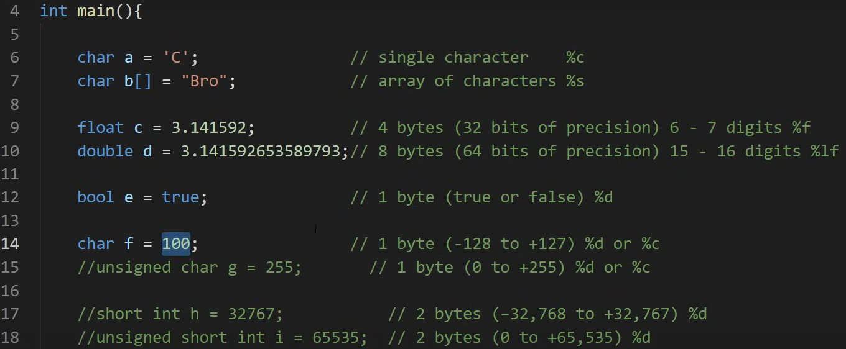

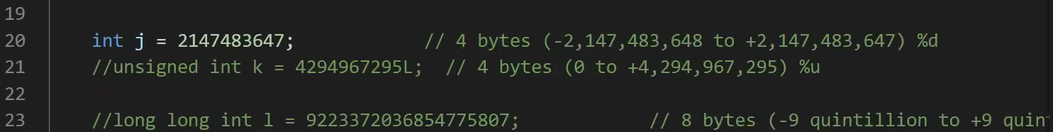

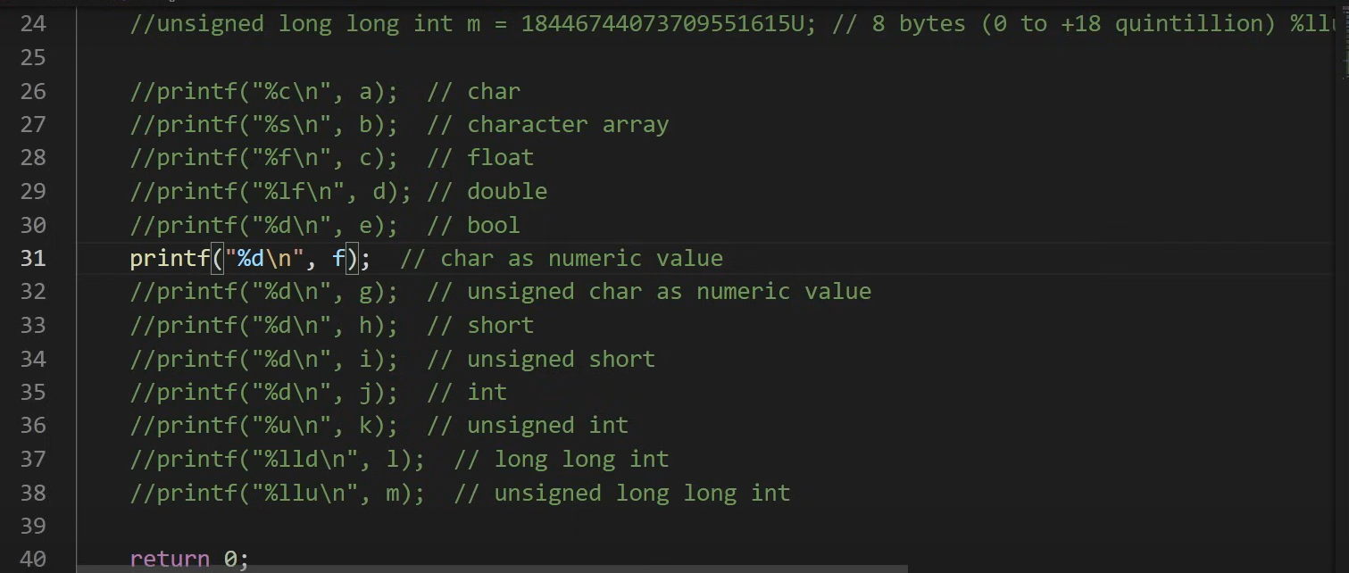

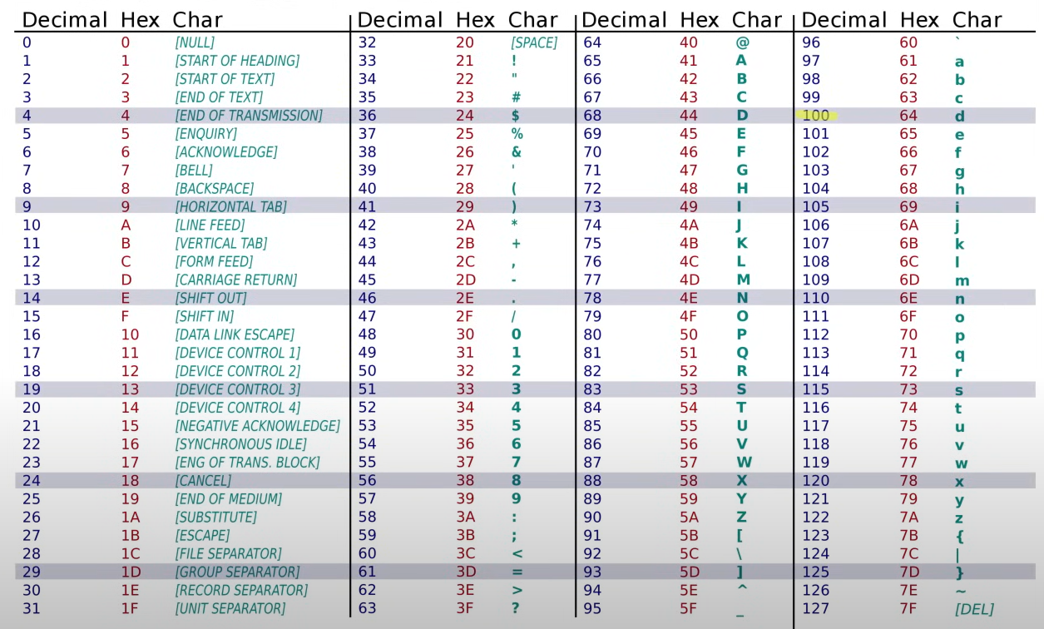

/******************************************************************************

                            Online C Compiler.

                Code, Compile, Run and Debug C program online.

Write your code in this editor and press "Run" button to compile and execute it.

*******************************************************************************/

# include <stdio.h>

// # include "nombre de archivo"

#define CUBO(a) a*a*a // MAcros are faster than functions

#define PI 3.14159

int suma();

int main()

{

const float PI_ = 3.1416

    int num1;

    int num2;

    int result; // 2 bytes de -32768 a 32767 ??

    char C = 'y'; // tamaño de 1 byte rango de 0 a 255

    short e = -1; // 2 bytes -128 a 127

    unsigned int u = 25; // 2 bytes 0 65535

    long l = 5932; // 4 bytes -2147483648 a 2147483647

    float f = 72.538; // 4 bytes

    double d = 12323.877658; // 8 bytes

bool e = false; // 1 byte

    printf("First num\n");

    scanf("%d", &num1);

    printf("Second num\n");

    scanf("%d", &num2);

    result = num1 + num2;

    printf("El resultado de la suma es: %d\n", result);

    if (result >=3) {

        printf("Result greater or equal to 3\n");

    } else {

        printf("Less than 3\n");

    }

    int a = 3;

    printf("El cubo de la variable con Macro es: %i\n",CUBO(a));

    printf("Character: %c\n",C);

    printf("Short: %i\n",e);

    printf("%li\n",l);

    printf("%.2lf\n",d);

    int contador=4;

    while(contador <= 6)

    {

        printf("%i\n",contador);

        contador++;

    }

    int count;

    for(count=1; count <=3; count++)

    {

        printf("%i\n", count);

    }

    int n = 1;

    do {

        printf("Val: %i\n", n);

        n++;

    } while (n<3);

    int cases;

    printf("Enter a num for a case:\n");

    scanf("%i", &cases);

    switch(cases) {

        case 1:

        printf("Case 1\n");

        break;

        case 2:

        printf("Case 2\n");

        break;

        default:

        printf("No case found\n");

        break;

    }

    int multi[2][3] = {{5,3,1},{6,4,2}};

    printf("%i\n",multi[1][1]);

    printf("%i\n", suma(num1, num2));

  return 0;

}

// Al usar void, la funcion no retorna valor

void saludo()

{

    printf("Hola\n");

}

int suma(int num1, int num2)

{

    int suma = num1 + num2;

    saludo();

    // apuntador tiene una variable que guarda una referencia al valor guardado en memoria

    int a=2;

    int *apt = &a; // apuntador *apt

    printf("%i\n",*apt);

    printf("%p\n", apt); // imprime el espacio de memoria en hexadecimal (la direccion en memoria) ej. 0x7fff2569c928

    return suma;

}

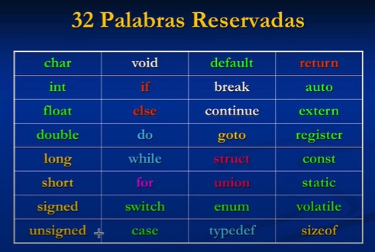

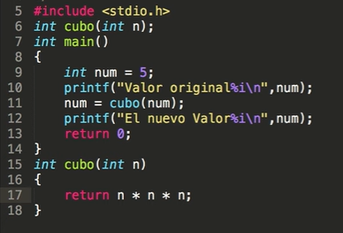

Llamada apuntador por referencia:

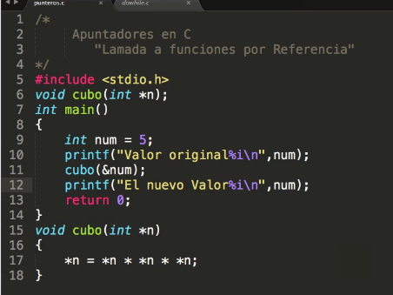

## Operador **sizeof**

size_t devuelve puros positivos, no se incluye el 0. lu es long unsigned

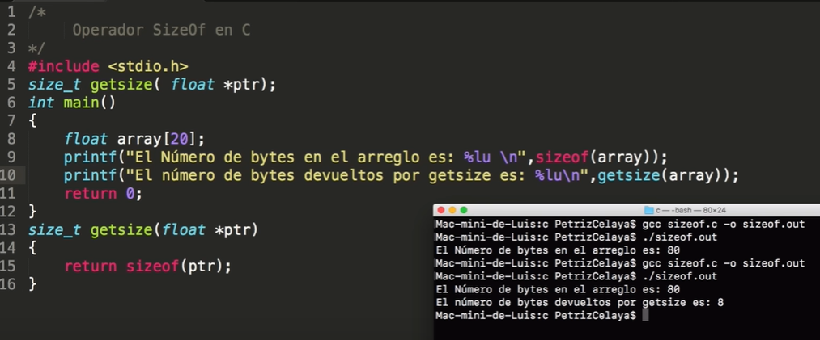

## Estructuras

structura es una coleccion de uno o varios miembros

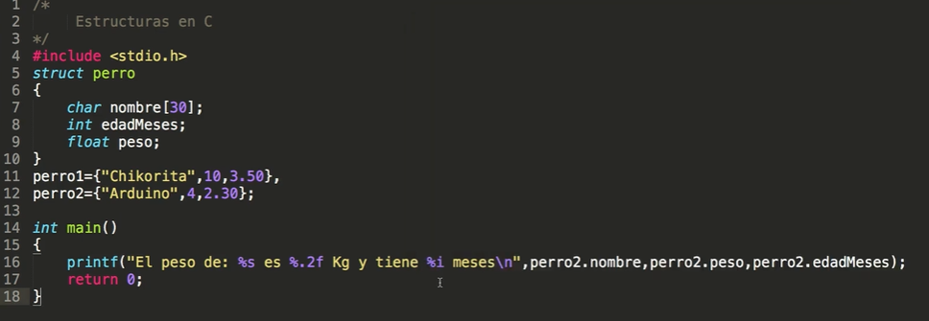

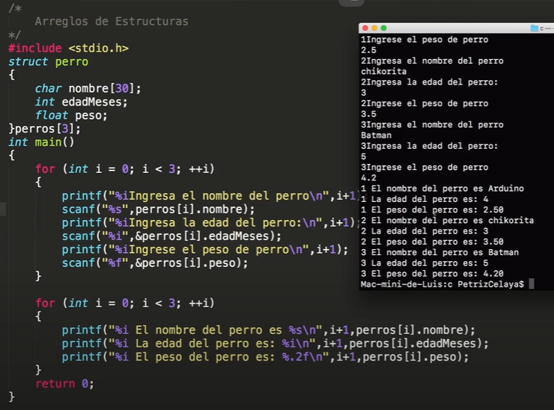

se declara una constante con #define, y es length con valor de 2

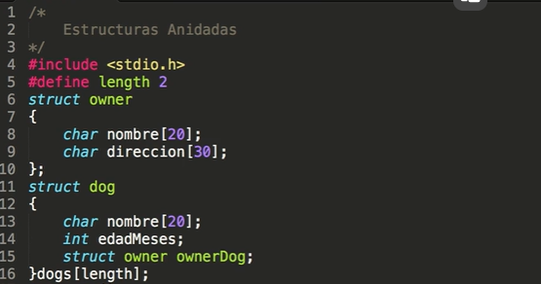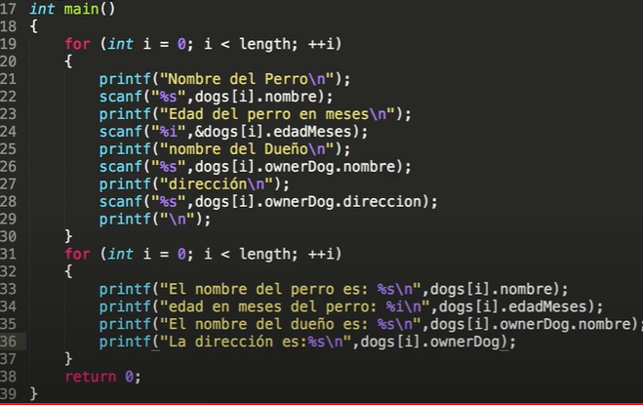

## **Math functions:**

[C Programming Full Course for free 🕹️ (youtube.com)](https://www.youtube.com/watch?v=87SH2Cn0s9A)

## **|| OR, && AND, ! NOT**

**Function with arguments:**

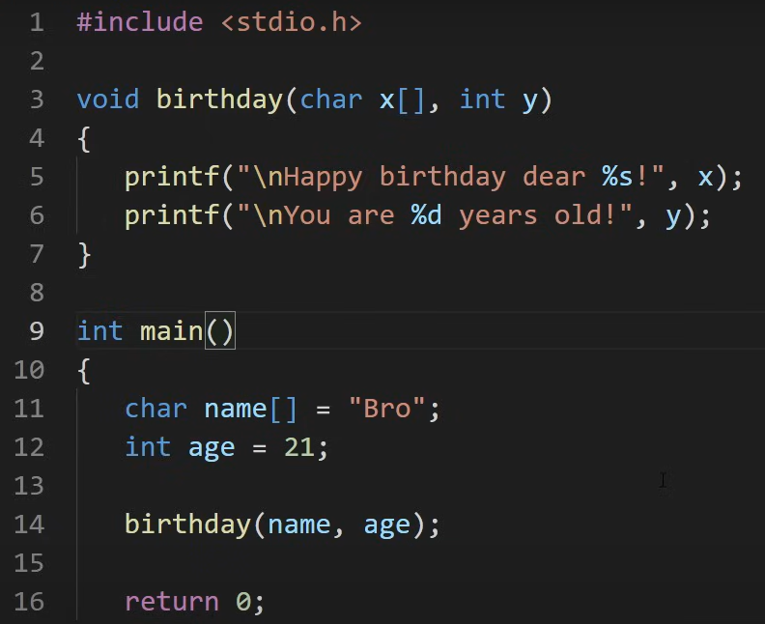 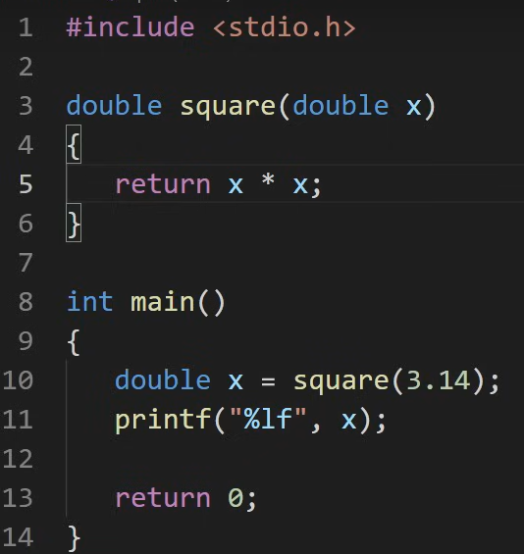

**Ternary operator:**

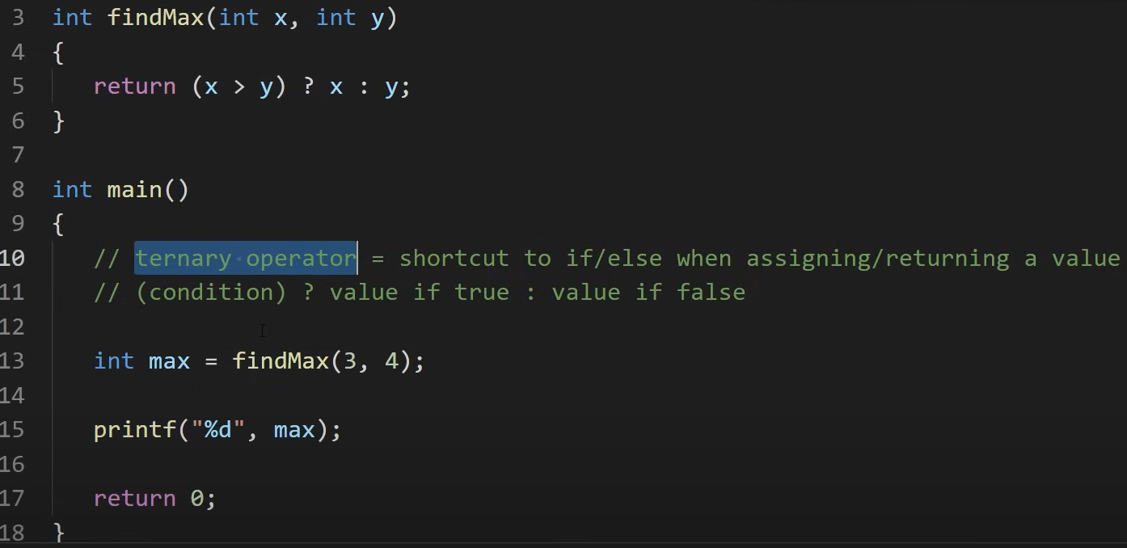

## Fucntion prototypes:

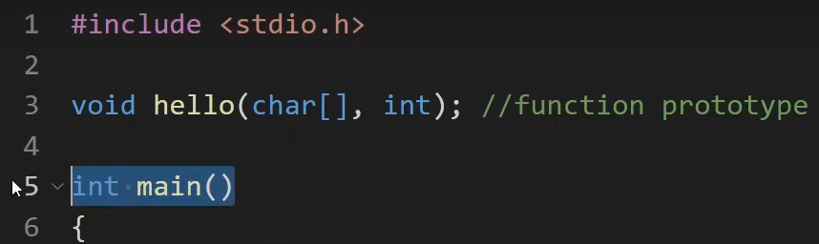

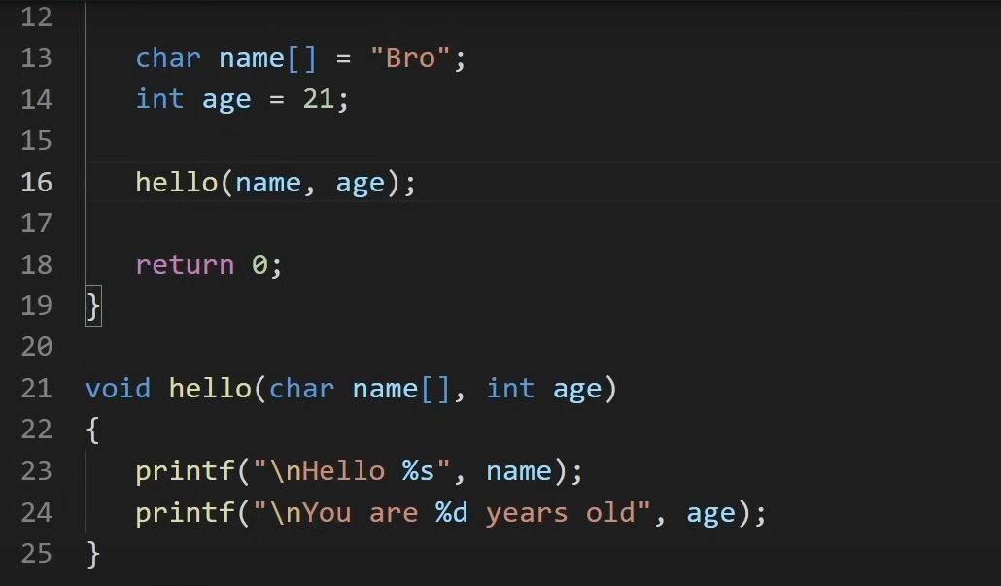

Some methods:  
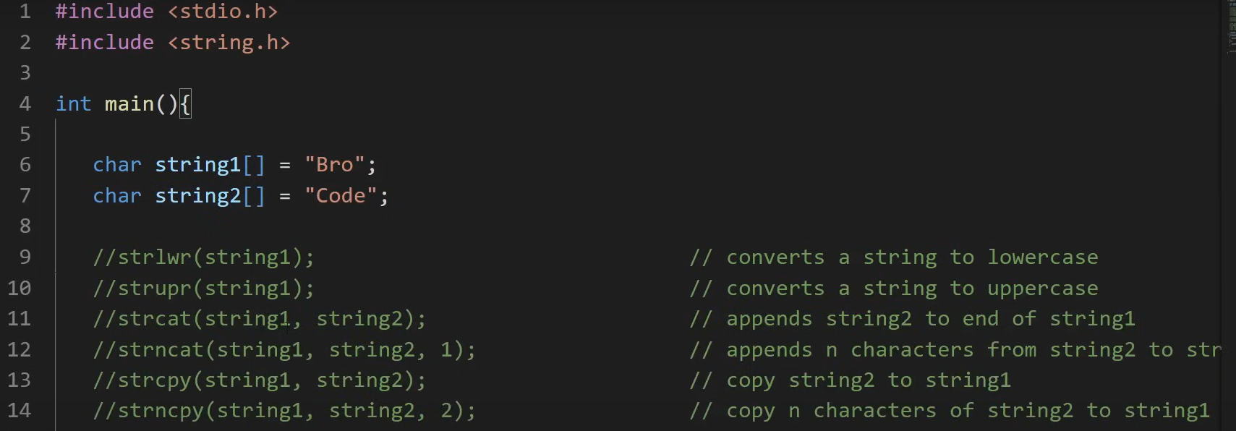

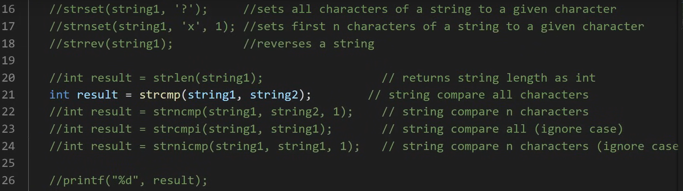

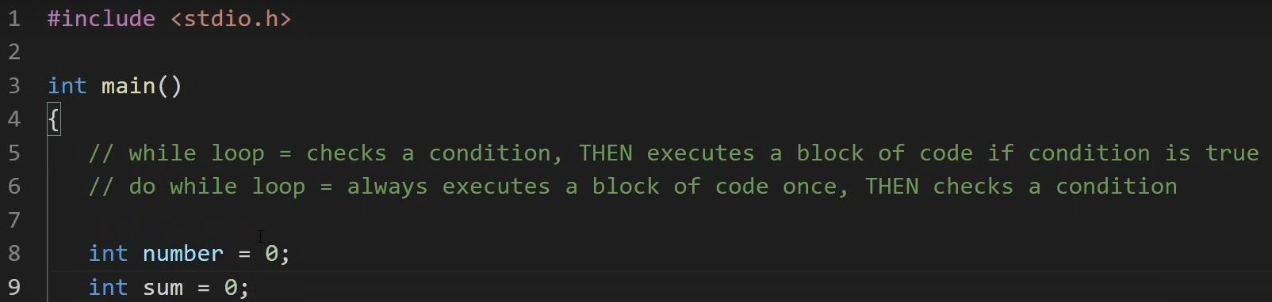

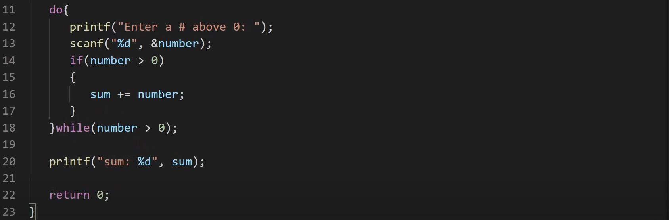

/******************************************************************************

                            Online C Compiler.

                Code, Compile, Run and Debug C program online.

Write your code in this editor and press "Run" button to compile and execute it.

*******************************************************************************/

#include <stdio.h>

#include <stdbool.h>

#include <string.h>

#include <ctype.h>  // Necesario para la función toupper()

int main()

{

    char unit;

    char x[] = "C";

    bool e = true;

    char name[25];

    printf("Hello World %s\n", x);

    if (e) {

        printf("True");

    } else {

        printf("False");

    }

    printf("\nWhat is your name?\n");

    fgets(name, 25, stdin);

    name[strlen(name)-1] = '\0';  // Esto es necesario porque fgets captura también el carácter de nueva línea cuando el usuario presiona Enter.

    // Entonces Elimina el caracter de nueva línea (\n) del final de la cadena name, reemplazándolo con el caracter nulo ('\0')

    printf("\nHi %s\n", name);

    unit = 'c';

    unit = toupper(unit);

    printf("Unit: %c\n", unit);

    return 0;

}

## **Array:**

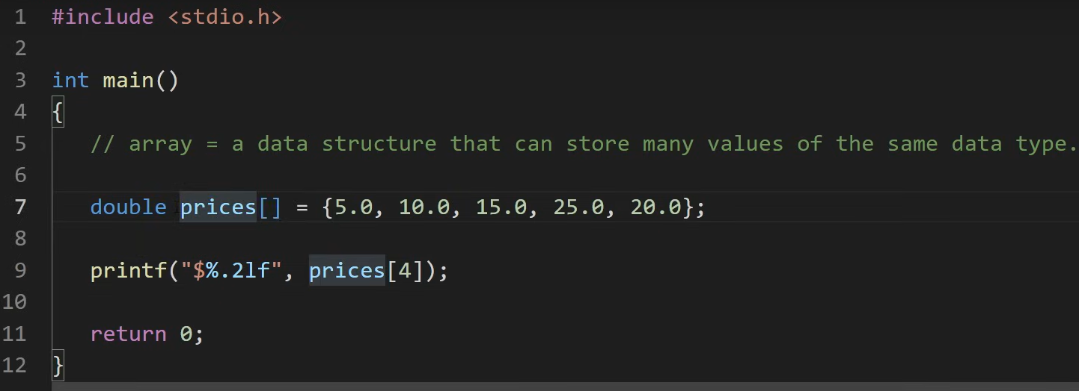

Copy to a third variable:  
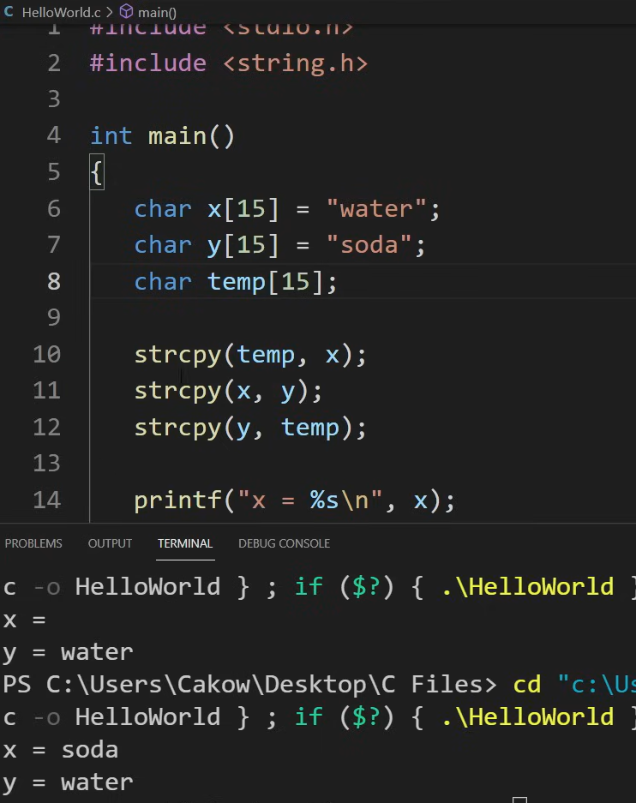

## Size of:

## Structure

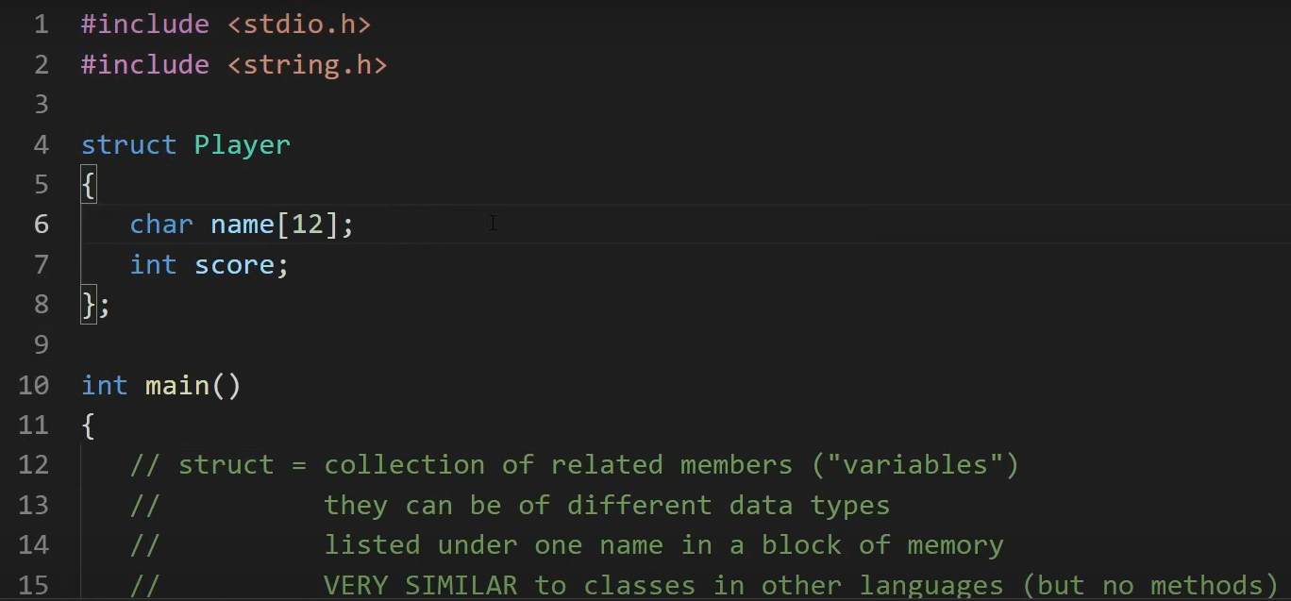

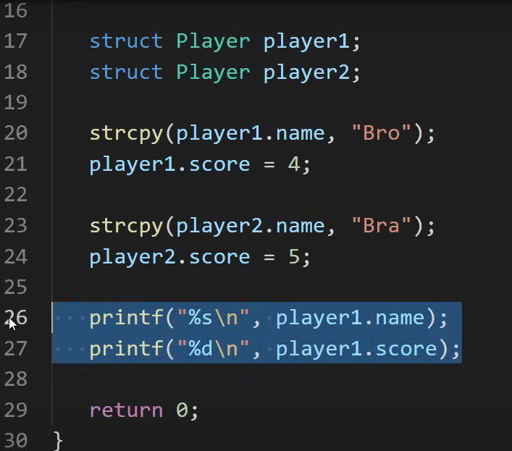

## Typedef to give to a datatype a ‘nickname’

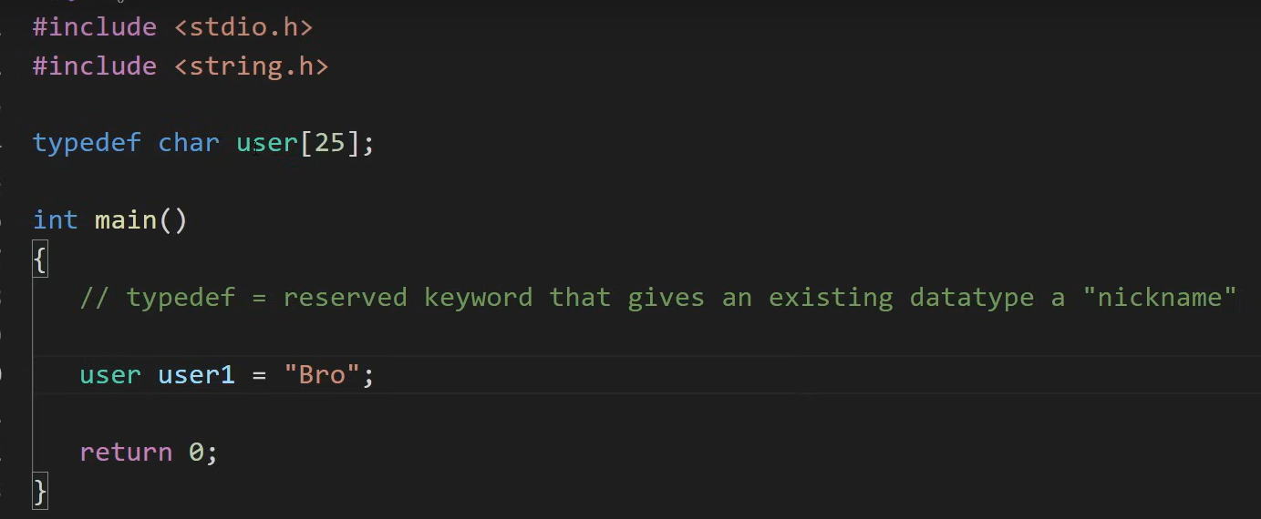

Example in a Structure

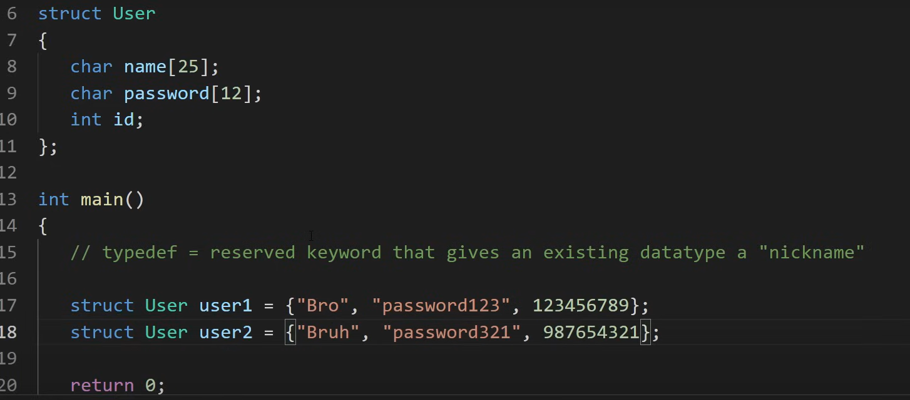

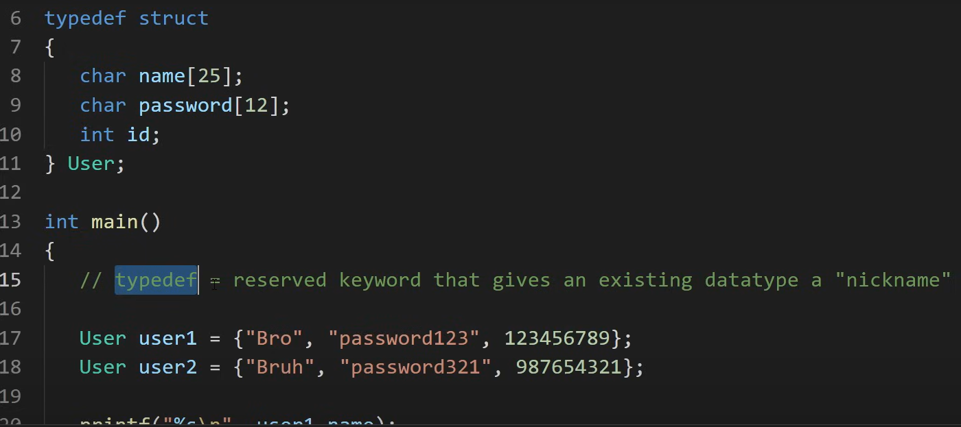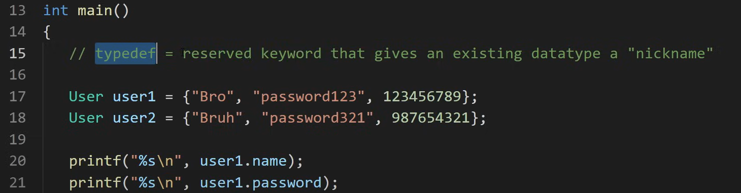

Example Struct, 12 characters for students name?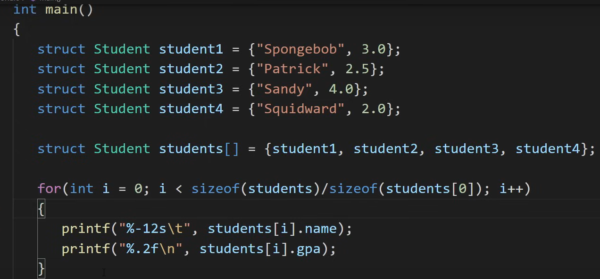

## Use of enum

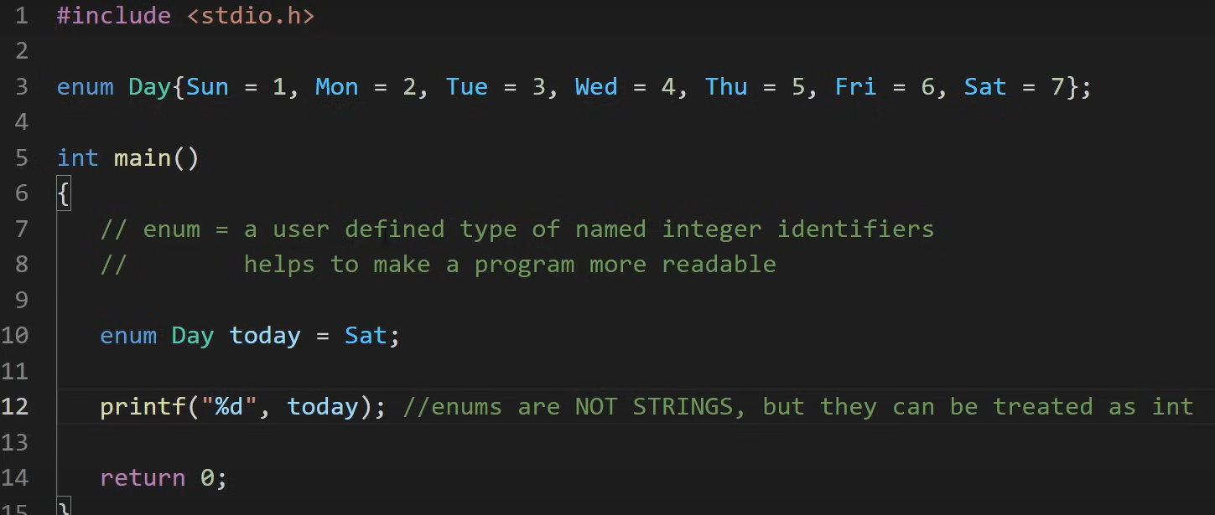

Or for example:



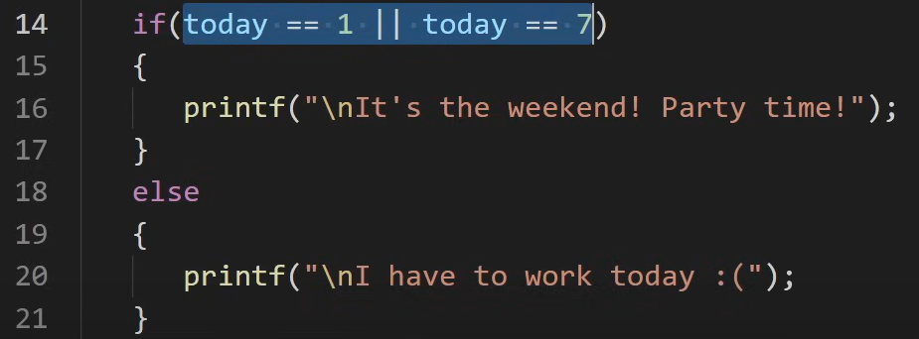

To me it more readable, instead of use integers:

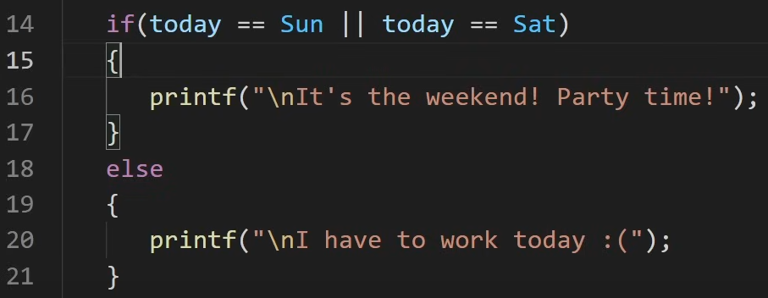

Random numbers between 1 and 6:

Srand(time(0)) uses the current time as seed

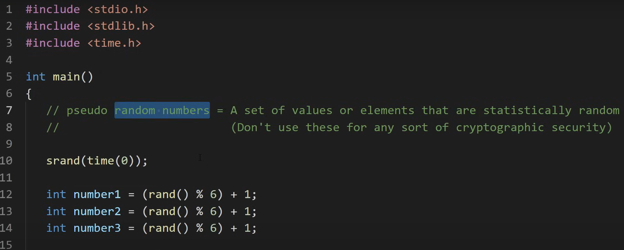

## BITWISE OPERATORS:

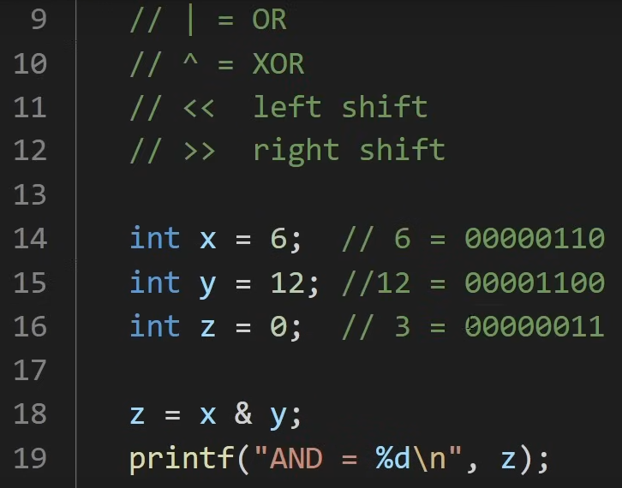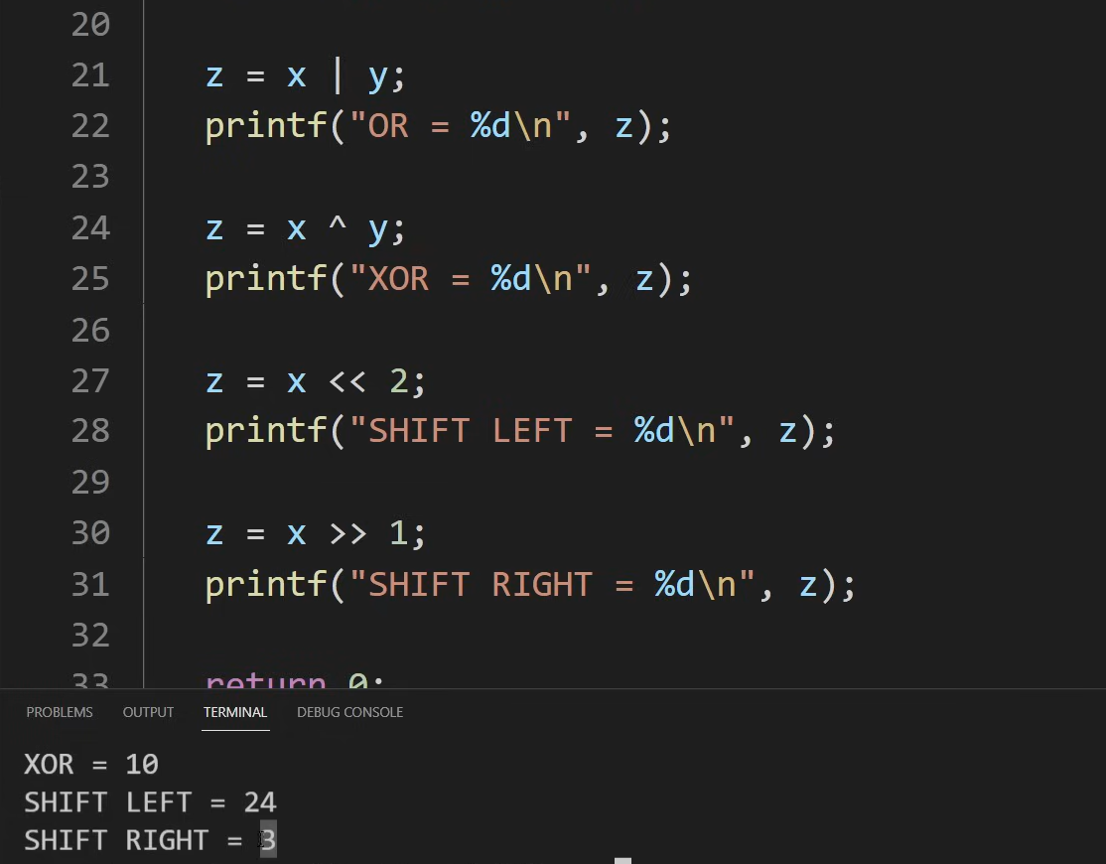

## **Memory:**

If we use short it uses more memory (2 bytes), int uses more (4 bytes) and double even more (8 bytes)

## **Pointers**

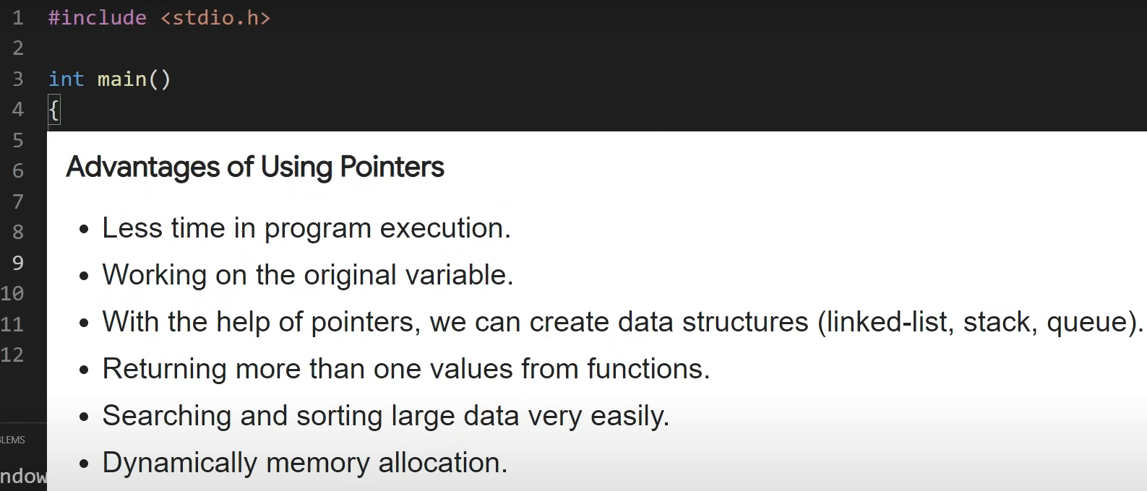

%p for show in heaxadecimal

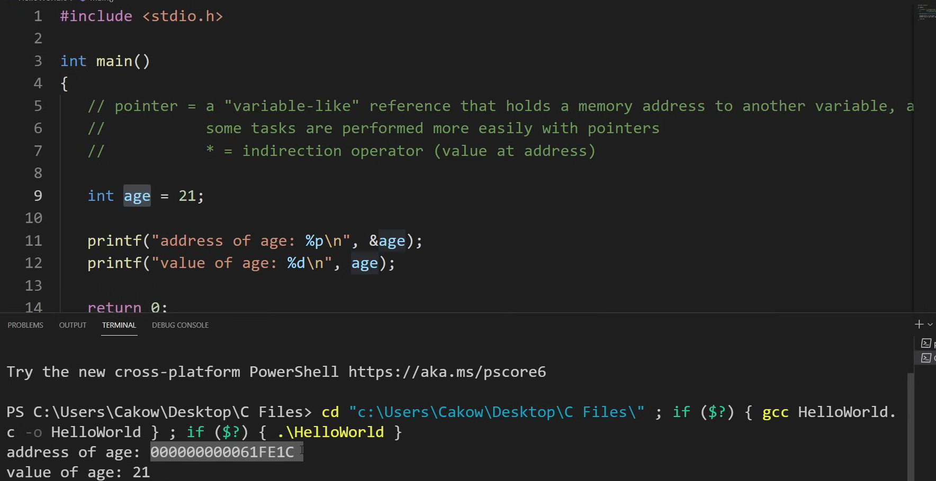

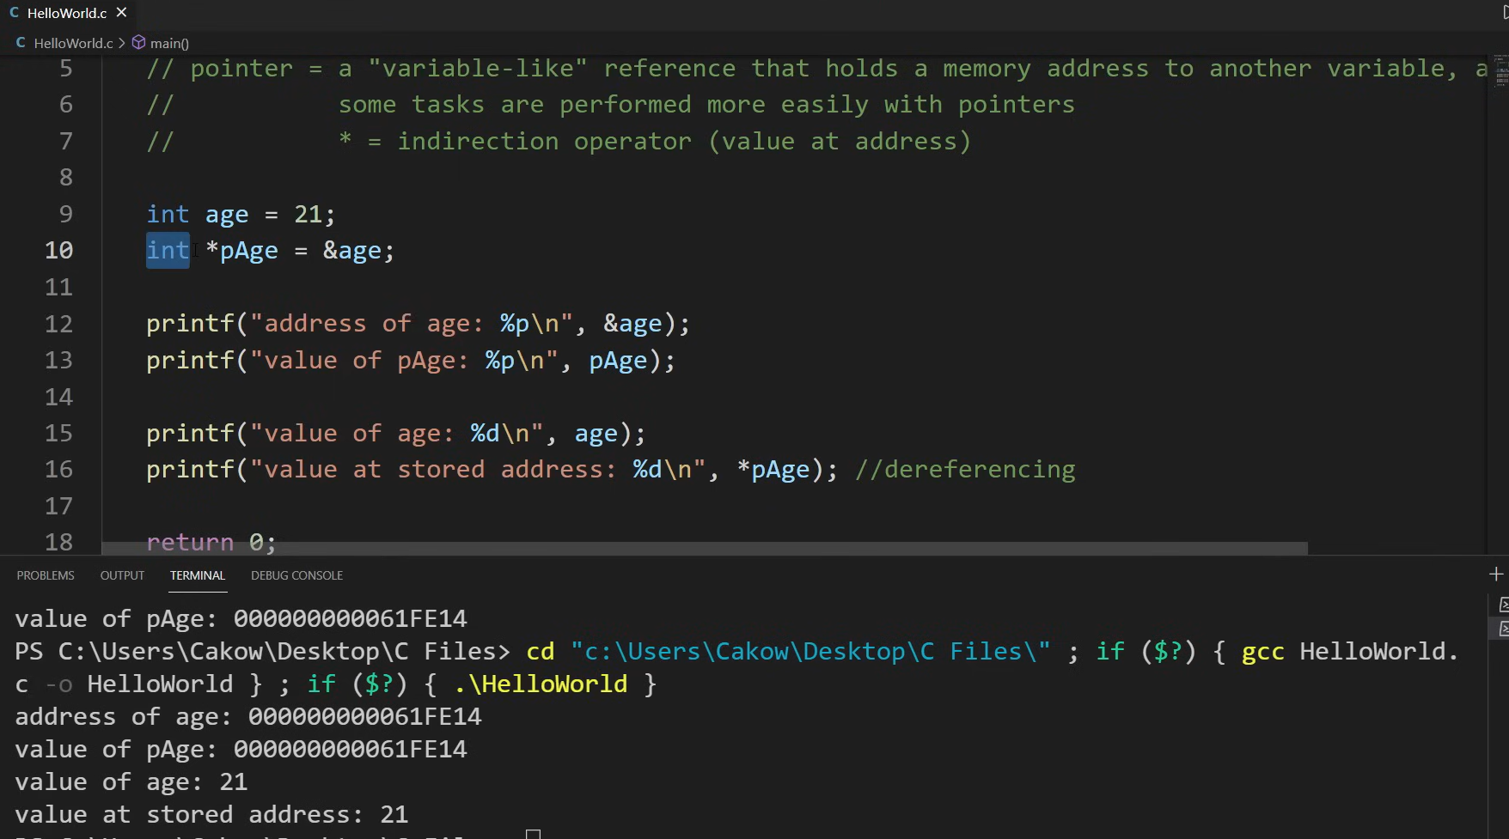

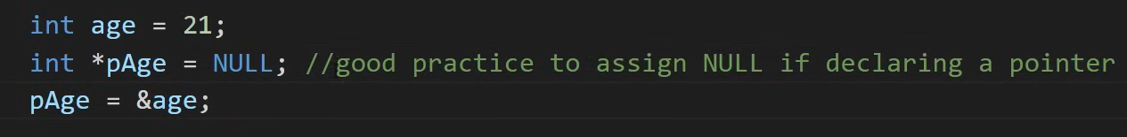

Add data to a file, or create a new file or read data from a file:

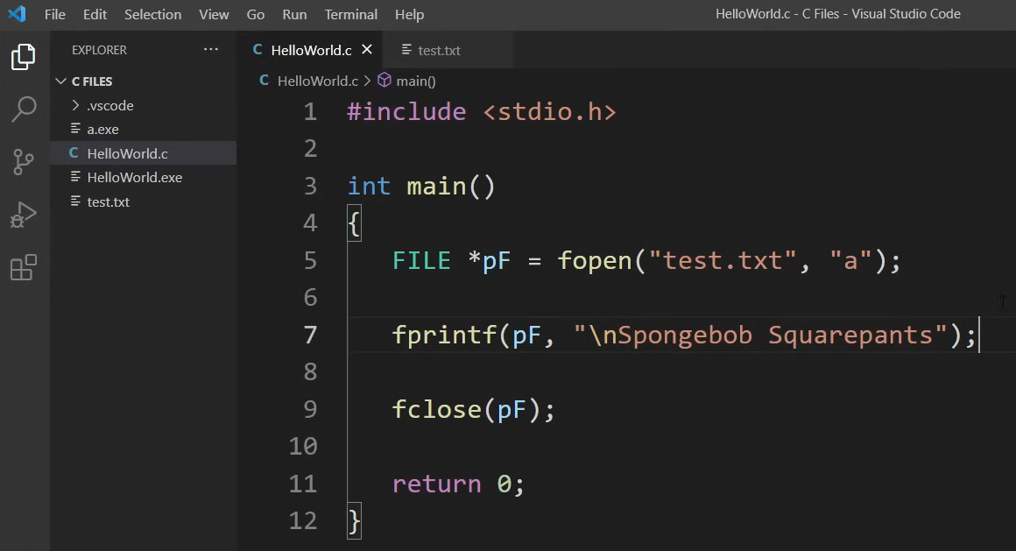

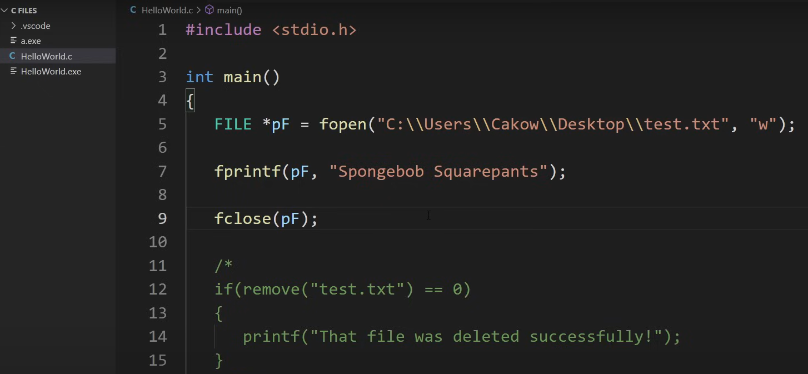

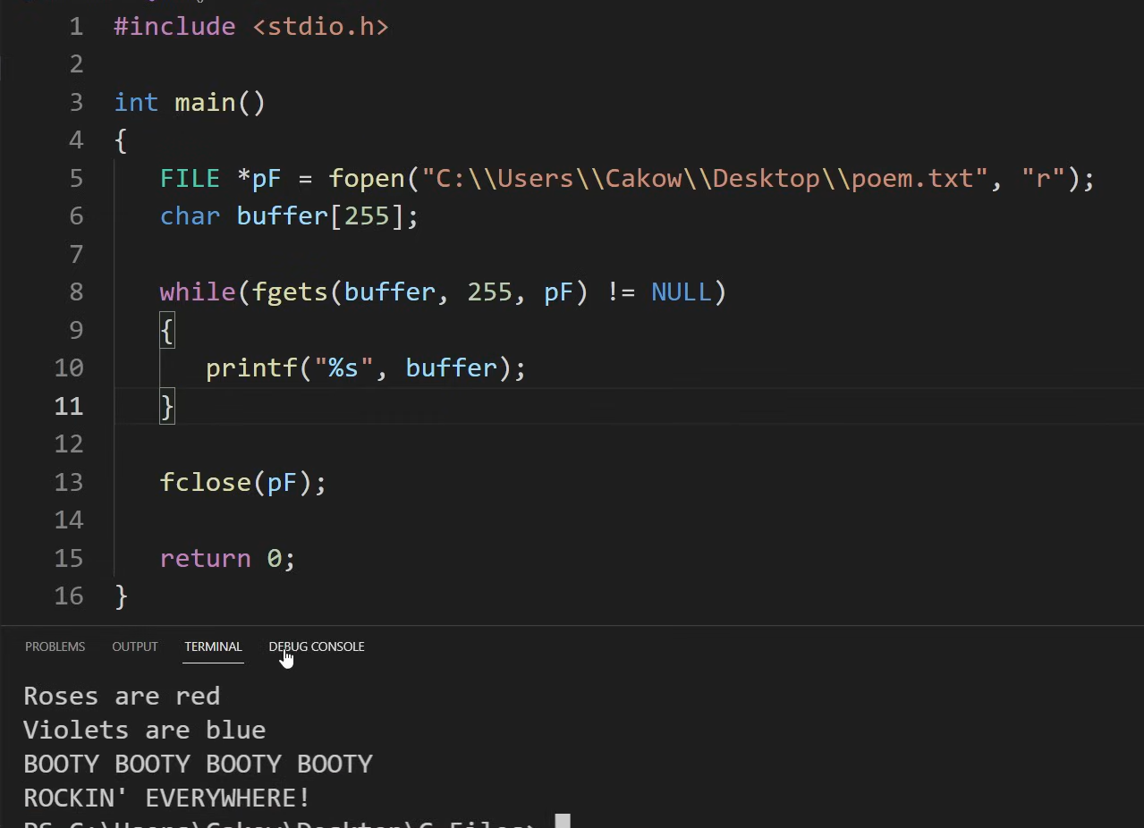

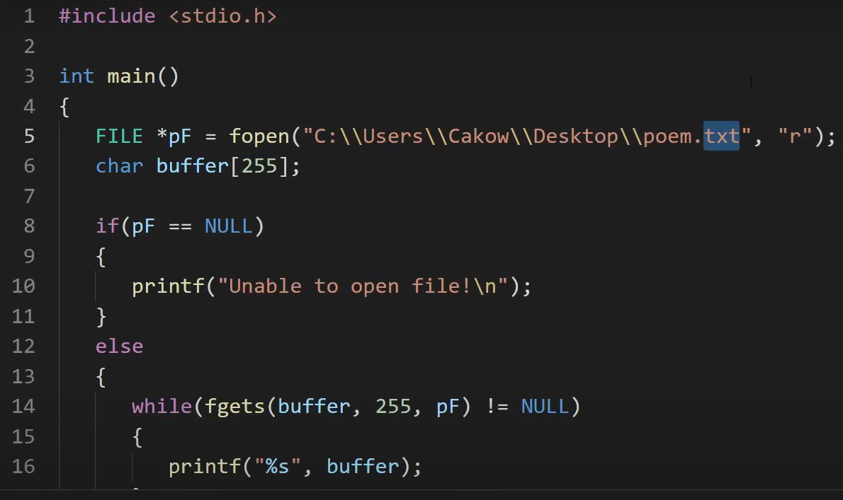

[C Programming Full Course for free 🕹️ - YouTube](https://www.youtube.com/watch?v=87SH2Cn0s9A)

# C++ [Tutorial C++ 10. Sentencias If (youtube.com)](https://www.youtube.com/watch?v=2y11TNNlIPs&list=PL4A486BBFC5AD733B&index=11)

#include <iostream>

#include <stdlib.h>

using namespace std;

char letr = 'w';

char* letter = "Codigo";

bool variable = true;

int main()

{

    std::cout<<"Hello World\n";

    cout << letr << "\n" << endl;

    cout << letter << endl;

    cout << variable << "\n\n" << endl;

    // system("PAUSE");  // para que no se cierre la consola

    return 0;

}

#include <iostream>

#include <stdlib.h>

// #include <conio.h>  // para que no se cierre la consola

using namespace std;

char letr = 'w';

char* letter = "Codigo";

bool variable = true;

int numb = 12;

const int numb2 = 4;

int operacion;

int main()

{

    float num = 22.313467;

    double num2 = 12.434507;  // mas precision que float, pero mas memoria

    int numb = 2;

    operacion = 12;

    operacion += 3;

    cout << num << endl;

    cout << num2 << endl;

    cout << numb << endl;

    cout << numb2 << endl;

    cout << operacion << endl;

    // getch();  // para que no se cierre la consola.

// También se puede usar cin.get() que es de la librería iostream

    return 0;

}

## Operadores de comparacion ==, !=, <, >, <=, >=, &&, ||, !

**Conditions**. If

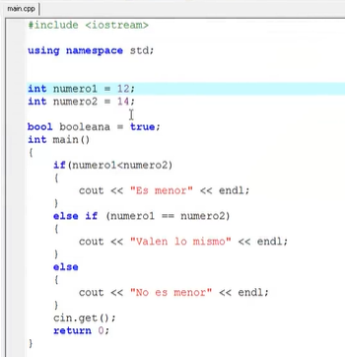

## Case:

#include <iostream>

using namespace std;

int main()

{

    char c;

    cout << "Escribe una letra:" << endl;

    cin >> c;

    switch(c)

    {

      case 'a':

      case 'e':

      case 'i':

      case 'o':

      case 'u':

        cout << "Es una vocal\n" << endl;

        break;

      default:

        cout << "Es una consonante\n" << endl;

    }

    // system("pause");

    return 0;

}

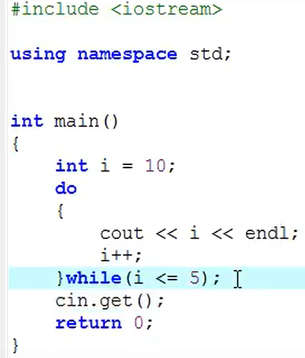 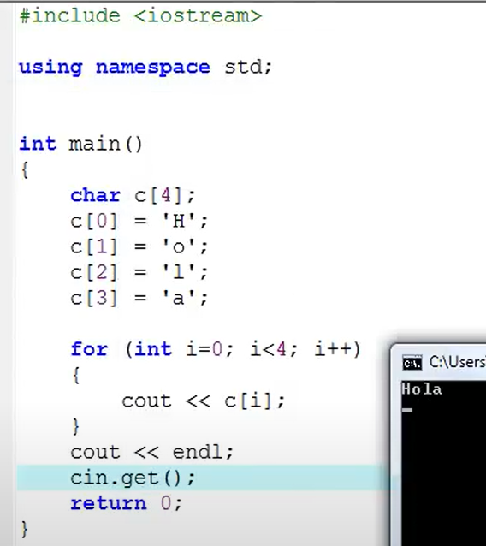

## Uso de include:

Uso "" si el archivo a incluir esta en el folder de mi proyecto.  
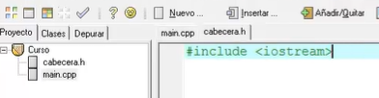

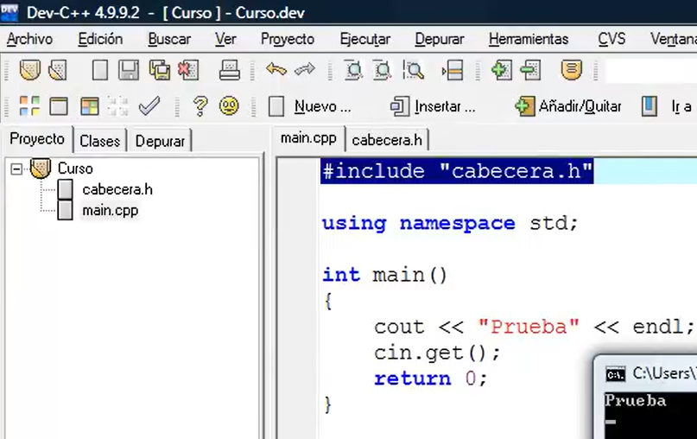

## **define** para sustitucion de algun identificador de la macro

#define sumar(a,b) a+b

#define dividir(a,b) a/b

#include <iostream>

int num1 = 2;

int num2 = 5;

int suma;

int divide;

int main() {

  suma = sumar(num1, num2);

  divide = dividir(num2, num1);

  std::cout << "La suma es: " << suma << std::endl;

  std::cout << "El cociente es: " << divide << std::endl;

  return 0;

}

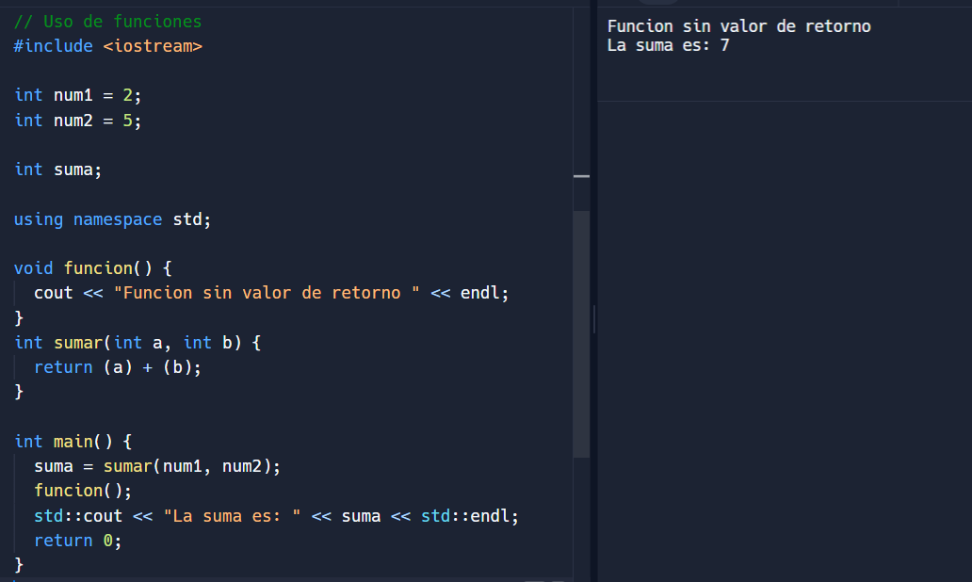

// Uso de funciones

#include <iostream>

int num1 = 2;

int num2 = 5;

int suma;

using namespace std;

void funcion() {

  cout << "Funcion sin valor de retorno " << endl;

}

int sumar(int a, int b) {

  return (a) + (b);

}

int main() {

  suma = sumar(num1, num2);

  funcion();

  std::cout << "La suma es: " << suma << std::endl;

  return 0;

}

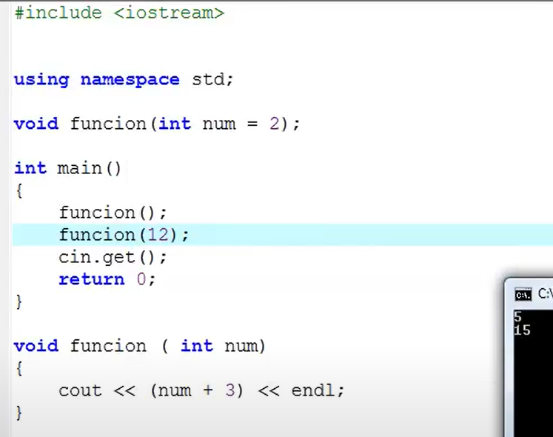

## Estructuras

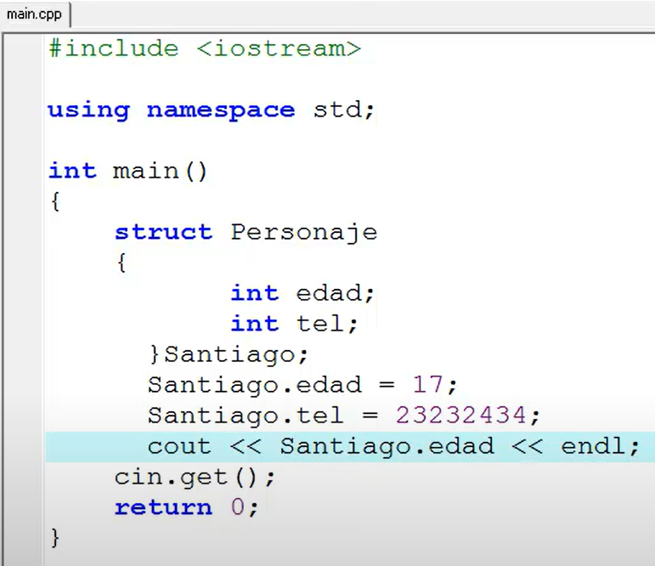

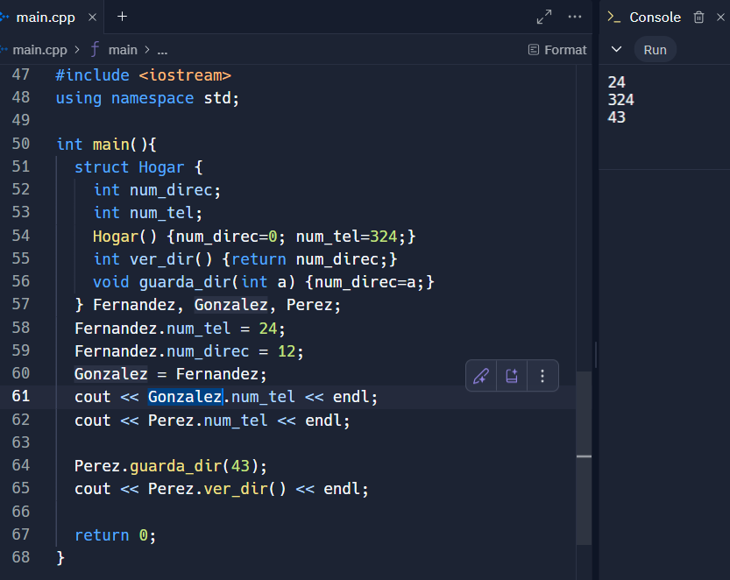

## Namespace

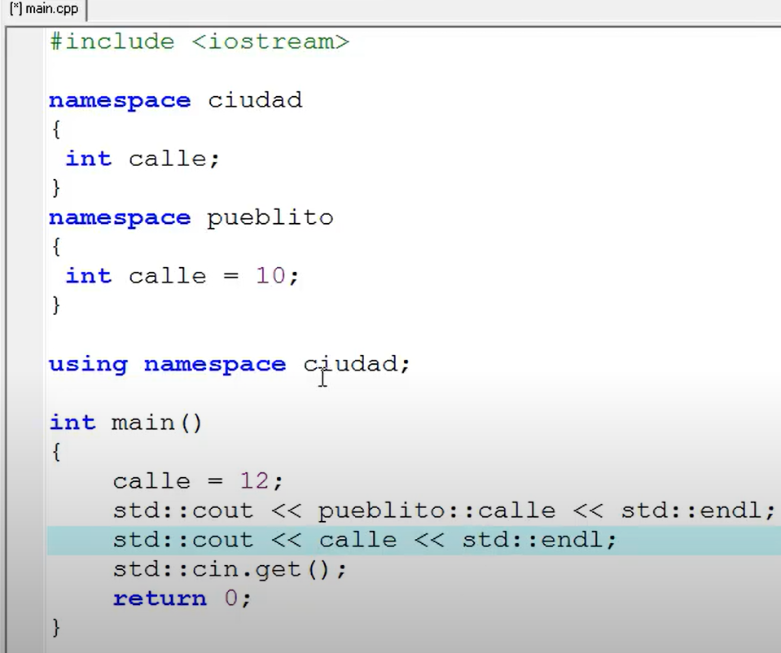

Uso de operador de referencia (&)

el puntero guarda la direccion de memoria de alguna variable

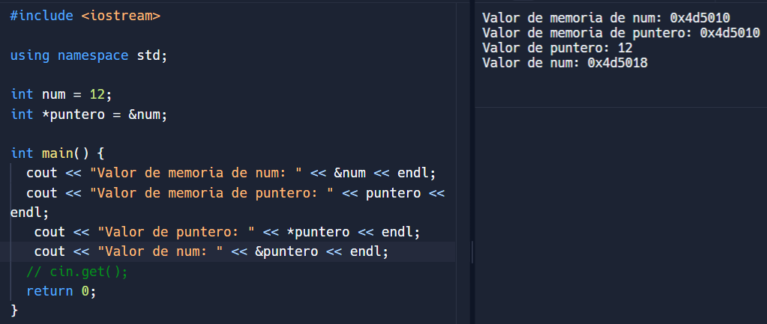

## Puntero en array

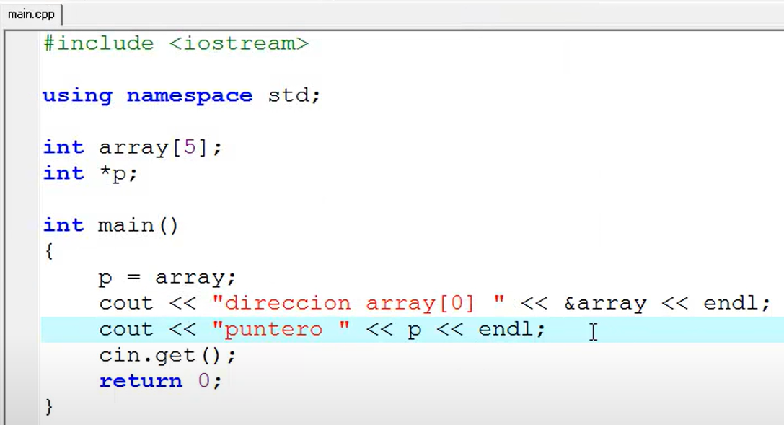

Si pongo p++ seria para la direccion del siguinete elemento del array, array[1]

Puntero en Estructura

#include <iostream>

using namespace std;

struct nuevaestructura {

  int a;

} nuevaestructura, *puntero;

int main() {

  nuevaestructura.a = 12;

  puntero = &nuevaestructura;

  cout << "Puntero: " << puntero << endl;

  cout << "memoria de a en structura: " << &nuevaestructura.a << endl;

   cout << "Valor de a: " << puntero->a << endl;

  // cin.get();

  return 0;

}

Devuelve:  
Puntero: 0x4d518c

memoria de a en structura: 0x4d518c

Valor de a: 12

## **Type def**

Cambiar un type por otro nombre: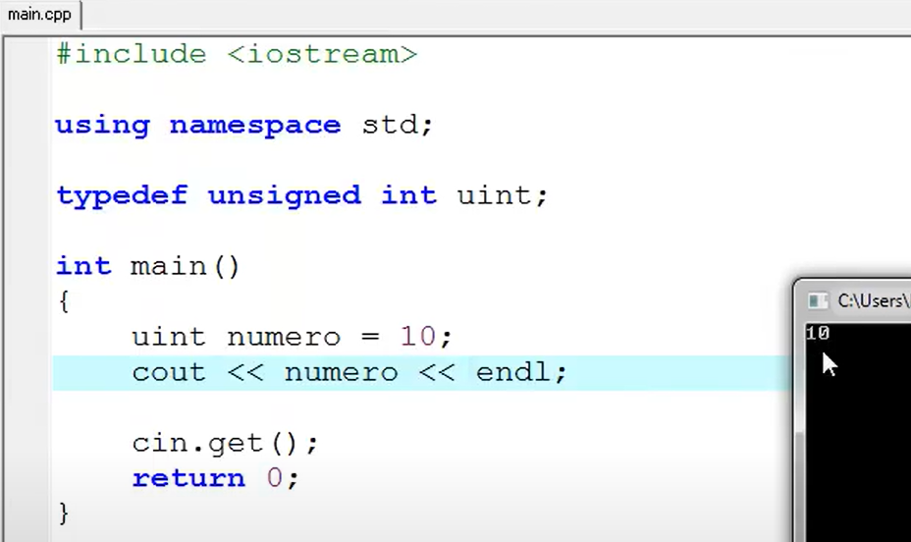

## Clases

Tienen datos publicos que pueden modificarse, llamarse desde afuera

Los privados son propios de la clase, no se pueden llamar fuera

Estan los protected, que no se pueden llamar fuera los datos, pero si se hereda la funcion, en la heredada como que si?

#include <iostream>

using namespace std;

class cuentas {

  public:

    int sumaDos(int arg);

    int sumaTres(int arg);

  private:

    int resultado;

};

int cuentas::sumaDos(int arg) {

  resultado = arg + 2;

  return resultado;

}

int cuentas::sumaTres(int arg) {

  resultado = arg + 3;

  return resultado;

}

int main() {

  cuentas cuenta;

  cout << "+ 2 = " << cuenta.sumaDos(2) << endl;

  cout << "+ 3 = " <<cuenta.sumaTres(2) << endl;

  cin.get();

  return 0;

}

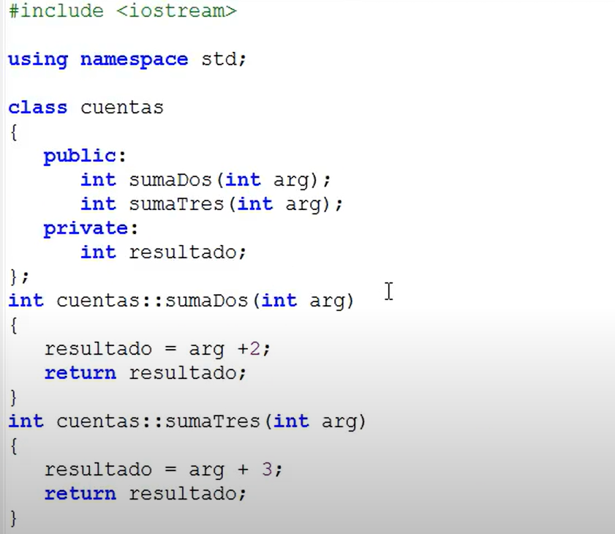

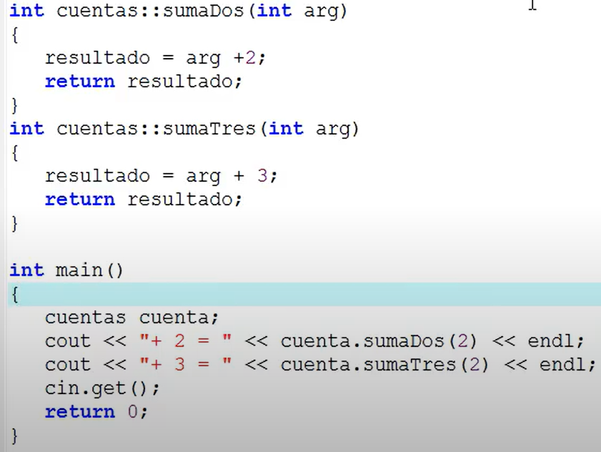 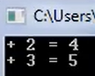

# **C#**

<https://www.linkedin.com/learning/learning-c-sharp-8581491/>

using System;

namespace VarsAndData

{

    class Program

    {

        static void Main(string[] args)

        {

            // Declare some basic value type variables

            int i = 10;

            float f = 2.0f;

            decimal d = 10.0m;

            bool b = true;

            char c = 'c';

            // Declare a string - it's a collection of characters

            string str = "a string";

            // Declare an implicit variable

            var x = 10;

            var z = "Hello!";

            // Declare an array of values

            int[] vals = new int[5];

            string[] strs = { "one", "two", "three" };

            // Print the values using a Formatting String

            Console.WriteLine("{0}, {1}, {2}, {3}, {4}, {5}, {6}, {7}", i, c, b, str, f, d, x, z);

            // "null" means "no value"

            object obj = null;

            Console.WriteLine(obj);

            // Implicit conversion between types

            long bignum;

            bignum = i;

            // Explicit conversions

            float i_to_f = (float)i;

            Console.WriteLine("{0}", i_to_f);

            int f_to_i = (int)f;

            Console.WriteLine("{0}", f_to_i);

        }

    }

}

## Operators

using System;

namespace Operators

{

    class Program

    {

        static void Main(string[] args)

        {

            // Declare some variables to excercise the operators

            int x=10, y=5;

            string a="abcd", b="efgh";

            // Basic math operators are +, -, /, *

            Console.WriteLine("----- Basic Math -----");

            Console.WriteLine((x / y) * x);

            Console.WriteLine(a + b);

            // Increment / decrement operators

            Console.WriteLine("----- Shorthand -----");

            x++;

            y--;

            Console.WriteLine(x);

            Console.WriteLine(y);

            // Operators can be shorthand: a = a + b

            a += b;

            Console.WriteLine(a);

            // Logical operators &&, ||

            Console.WriteLine("----- Logic Operators -----");

            Console.WriteLine(x > y && y >= 5);

            Console.WriteLine(x > y || y >= 5);

            // null-coalescing operators

            string str = null;

            // the ?? operator uses left operand if not null, or right one if it is

            Console.WriteLine(str ?? "Unknown string");

            // the ??= operator assigns the right operand if the left one is null

            // it replaces the code:

            // if (variable is null) {

            //    variable = somevalue;

            // }

            str ??= "New string";

            Console.WriteLine(str);

        }

    }

}

## Conditional If, and Ternary operator

using System;

namespace Conditionals

{

    class Program

    {

        static void Main(string[] args)

        {

            int theVal = 50;

            // if-else

            if (theVal == 50) {

                Console.WriteLine("theVal is 50");

            }

            else if (theVal >= 51 && theVal <= 60) {

                Console.WriteLine("theVal is between 51 and 60");

            }

            else {

                Console.WriteLine("theVal is something else");

            }

            // -----------------------

            // Using the ternary operator ?:

            // a two-case if-then

            if (theVal < 50) {

                Console.WriteLine("theVal is small");

            }

            else {

                Console.WriteLine("theVal is large");

            }

            // can be replaced by a ternary operator ?:

            Console.WriteLine(theVal < 50 ? "theVal is small" : "theVal is large");

        }

    }

}

## Switch

using System;

namespace ConditionalOps

{

    class Program

    {

        static void Main(string[] args)

        {

            int theVal = 50;

            // The switch statement

            switch (theVal) {

                case 50:

                    Console.WriteLine("The value is 50");

                    break;

                case 51:

                    Console.WriteLine("The value is 51");

                    break;

                case 52:

                case 53:

                case 54:

                    Console.WriteLine("The value is between 52 and 54");

                    break;

                default:

                    Console.WriteLine("The value is something else");

                    break;

            }

        }

    }

}

## For Loop, Foreach

using System;

namespace ForLoops

{

    class Program

    {

        static void Main(string[] args)

        {

            int myVal = 15;

            int[] nums = new int[] {3, 14, 15, 92, 6};

            string str = "The quick brown fox jumps over the lazy dog";

            // the basic for loop

            Console.WriteLine("The basic for loop:");

            for (int i = 0; i < myVal; i++) {

                Console.WriteLine("i is currently {0}", i);

            }

            Console.WriteLine();

            // the foreach-in loop can be used to iterate over sequences

            Console.WriteLine("The foreach loop:");

            foreach (int i in nums) {

                Console.WriteLine("i is currently {0}", i);

            }

            // count the number of o's in the string

            var count = 0;

            foreach (char c in str) {

                if (c == 'o') {

                    count++;

                }

            }

            Console.WriteLine("Counted {0} o characters", count);

        }

    }

}

## While Loop

using System;

namespace WhileLoops

{

    class Program

    {

        static void Main(string[] args)

        {

            string inputStr = "";

            // basic while loop executes while the gate condition is true

            Console.WriteLine("Basic while() loop:");

            while (inputStr != "exit") {

                inputStr = Console.ReadLine();

                Console.WriteLine("You entered: {0}", inputStr);

            }

            Console.WriteLine();

            // the do-while loop always executes at least one time

            Console.WriteLine("The  do-while() loop:");

            do {

                inputStr = Console.ReadLine();

                Console.WriteLine("You entered: {0}", inputStr);

            } while (inputStr != "exit");

            Console.WriteLine();

        }

    }

}

## Break-continue

using System;

namespace BreakContinue

{

    class Program

    {

        static void Main(string[] args)

        {

            int[] values = {15, 7, 12, 23, 41, 28, 9, 17, 36};

            Console.WriteLine("Using break and continue :");

            foreach (int val in values)

            {

                // The continue statement skips the rest of the loop entirely

                // and jumps to the next iteration (if there is one)

                if (val >= 20 && val <= 29) {

                    continue;

                }

                // print the value

                Console.WriteLine($"val is currently {val}");

                // The break statement stops the loop and exits

                if (val >= 40) {

                    break;

                }

            }

        }

    }

}

## Exceptions

using System;

namespace Exceptions

{

    class Program

    {

        static void Main(string[] args)

        {

            int x = 100;

            int y = 10;

            int result;

            try {

                if (x > 1000) {

                    throw new ArgumentOutOfRangeException("x","x has to be 1000 or less");

                }

                result = x / y;

                Console.WriteLine("The result is: {0}", result);

            }

            catch (DivideByZeroException e) {

                Console.WriteLine("Whoops!");

                Console.WriteLine(e.Message);

            }

            catch (ArgumentOutOfRangeException e) {

                Console.WriteLine("Sorry, 1000 is the limit");

                Console.WriteLine(e.Message);

            }

            finally {

                Console.WriteLine("This code always runs.");

            }

        }

    }

}

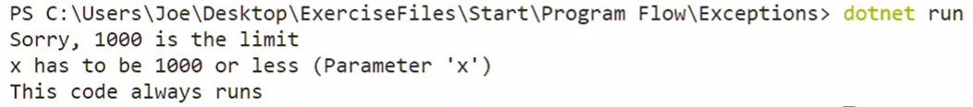

## String operations

using System;

namespace Operations

{

    class Program

    {

        static void Main(string[] args)

        {

            // Declare some strings for the exercises

            string outstr;

            string str1 = "The quick brown fox jumps over the lazy dog.";

            string str2 = "This is a string";

            string str3 = "THIS is a STRING";

            string[] strs = {"one", "two", "three", "four"};

            // Length of a string

            Console.WriteLine(str1.Length);

            // Access individual characters

            Console.WriteLine(str1[14]);

            // iterate over a string like any other sequence of values

            foreach (Char ch in str1) {

                Console.Write(ch);

                if (ch == 'b') {

                    Console.WriteLine();

                    break;

                }

            }

            // String Concatenation

            outstr = String.Concat(strs);

            Console.WriteLine(outstr);

            // Joining strings together with Join

            outstr = String.Join('.', strs);

            Console.WriteLine(outstr);

            outstr = String.Join("---", strs);

            Console.WriteLine(outstr);

            // String Comparison

            // Compare will perform an ordinal comparison and return:

            // < 0 : first string comes before second in sort order

            // 0 : first and second strings are same position in sort order

            // > 0 : first string comes after the second in sort order

            int result = String.Compare(str2, "This is a string");

            Console.WriteLine("{0}", result);

            // Equals just returns a regular Boolean

            bool isEqual = str2.Equals(str3);

            Console.WriteLine("{0}", isEqual);

            // String Searching

            Console.WriteLine("{0}", str1.IndexOf('e'));

            Console.WriteLine("{0}", str1.IndexOf("fox"));

            Console.WriteLine("{0}", str1.LastIndexOf('e'));

            Console.WriteLine("{0}", str1.LastIndexOf("the"));

            outstr = str1.Replace("fox", "cat");

            Console.WriteLine("{0}", outstr);

            Console.WriteLine("{0}", outstr.IndexOf("fox"));

        }

    }

}

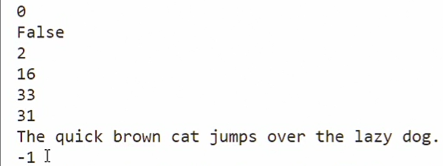

[Hello World - Introductory interactive tutorial | Microsoft Learn](https://learn.microsoft.com/en-us/dotnet/csharp/tour-of-csharp/tutorials/hello-world?tutorial-step=3)

## String Formatting

using System;

namespace Formatting

{

    class Program

    {

        static void Main(string[] args)

        {

            int[] quarters = {1,2,3,4};

            int[] sales = {100000, 150000, 200000, 225000};

            double[] intlMixPct = {.386, .413, .421, .457};

            string str1 = "TestStr";

            int val1 = 1234;

            decimal val2 = 1234.5678m;

            // Basic Formatting information

            Console.WriteLine("{0}", str1);

            // Specifying Numerical formatting

            // General format is {index[,alignment]:[format]}

            // Common types are N (Number), G (General), F (Fixed-point),

            // E (Exponential), D (Decimal), P (Percent), X (Hexadecimal),

            // C (Currency in local format)

            Console.WriteLine("{0:D}, {0:N}, {0:F}, {0:G}", val1);

            Console.WriteLine("{0:E}, {0:N}, {0:F}, {0:G}", val2);

            // Add a number after the format to specify precision

            Console.WriteLine("{0:D6}, {0:N2}, {0:F1}, {0:G3}", val1);

            // Formatting with alignment and spacing

            Console.WriteLine("Sales by Quarter:");

            Console.WriteLine("{0,12} {1,12} {2,12} {3,12}",quarters[0],quarters[1],quarters[2],quarters[3]);

            Console.WriteLine("{0,12:C0} {1,12:C0} {2,12:C0} {3,12:C0}",sales[0],sales[1],sales[2],sales[3]);

            Console.WriteLine("International Sales:");

            Console.WriteLine("{0,12:P0} {1,12:P0} {2,12:P1} {3,12:P2}",intlMixPct[0],intlMixPct[1],intlMixPct[2],intlMixPct[3]);

        }

    }

}

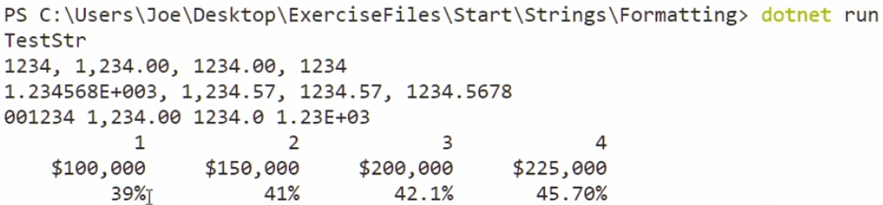

[Standard numeric format strings - .NET | Microsoft Learn](https://learn.microsoft.com/en-us/dotnet/standard/base-types/standard-numeric-format-strings)

"C" is the code for currency, and the number immediately following the code is the precision. Example: {0:C3}

## String interpolation

using System;

namespace StringInterpolation

{

    class Program

    {

        static void Main(string[] args)

        {

            // Declare some variables

            string make = "Mercedes-Benz";

            string model = "G Class";

            int year = 2020;

            float miles = 8_450.27f;

            decimal price = 60_275.0m;

            // Using string interpolation

            Console.WriteLine($"This car is a {year} {make} {{{model}}}, with {miles} miles and costs {price:C2}");

            // With inline expressions

            Console.WriteLine($"This car is a {year} {make} {{{model}}}, with {miles *1.6:F2} kilometers and costs {price:C2}");

        }

    }

}

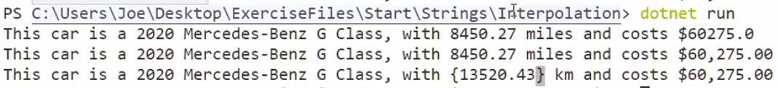

## String Builder

Easy way to work with strings

using System;

using System.Text;

namespace Builder

{

    class Program

    {

        static void Main(string[] args)

        {

            StringBuilder sb = new StringBuilder("Initial String. ", 200);

            int jumpCount = 10;

            string[] animals = {"goats", "cats", "pigs"};

            // print some basic stats about the StringBuilder

            Console.WriteLine($"Capacity: {sb.Capacity}; Length: {sb.Length}");

            // Add some strings to the builder using Append

            sb.Append("The quick brown fox ");

            sb.Append("jumps over the lazy dog.");

            // AppendLine can append a line ending

            sb.AppendLine();

            // AppendFormat can be used to append formatted strings

            sb.AppendFormat("He did this {0} times.", jumpCount);

            sb.AppendLine();

            // AppendJoin can iterate over a set of values

            sb.Append("He also jumped over ");

            sb.AppendJoin(",", animals);

            // Modify the content using Replace

            sb.Replace("fox", "cat");

            // Insert content at any index

            sb.Insert(0, "This is the ");

            Console.WriteLine($"Capacity: {sb.Capacity}; Length: {sb.Length}");

            // Convert to a single string

            Console.WriteLine(sb.ToString());

        }

    }

}

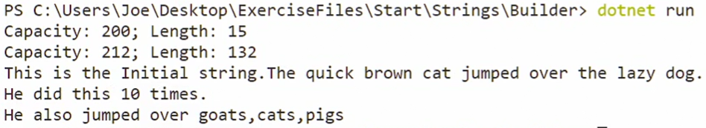

[StringBuilder Class (System.Text) | Microsoft Learn](https://learn.microsoft.com/en-us/dotnet/api/system.text.stringbuilder?view=net-8.0)

## String Parsing

using System;

using System.Globalization;

namespace Parsing

{

    class Program

    {

        static void Main(string[] args)

        {

            string numStr1 = "1";

            string numStr2 = "2.00";

            string numStr3 = "3,000";

            string numStr4 = "3,000.00";

            // The Parse function attempts to parse a string into a number

            // but it might throw an exception, so we need to catch that

            int targetNum;

            try {

                // Use Parse to try a simple integer

                targetNum = int.Parse(numStr1);

                Console.WriteLine($"{targetNum}");

                // Use Parse to try a floating point number

                // This only works if the decimal value is 0

                targetNum = int.Parse(numStr2, NumberStyles.Float);

                Console.WriteLine($"{targetNum}");

                // Use Parse to try a number with thousands marker

                targetNum = int.Parse(numStr3, NumberStyles.AllowThousands);

                Console.WriteLine($"{targetNum}");

                // Use Parse to try a number with thousands marker AND decimal

                targetNum = int.Parse(numStr4, NumberStyles.AllowThousands | NumberStyles.Float);

                Console.WriteLine($"{targetNum}");

                // This works with other types too, like bool

                Console.WriteLine($"{bool.Parse("True")}");

                // Or floating point numbers

                Console.WriteLine($"{float.Parse("1.235"):F2}");

            }

            catch {

                Console.Write("Conversion failed");

            }

            // The TryParse function is similar but handles the exceptions for us

            bool succeeded = false;

            succeeded = Int32.TryParse(numStr1, out targetNum);

            if (succeeded) {

                Console.WriteLine($"{targetNum}");

            }

        }

    }

}

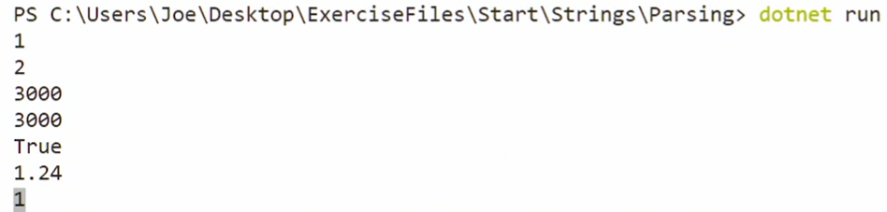

## Code challenge

Return true if the type of Arg matches the string that describes the type

// C# code​​​​​​‌​‌‌​‌‌​​​‌‌​​‌​​‌‌​​‌​​​ below

using System;

// Write your answer here, and then test your code.

// Your job is to implement the findLargest() method.

public class Answer {

    // Change these Boolean values to control whether you see

    // the expected result and/or hints.

    public  static Boolean ShowExpectedResult = false;

    public  static Boolean ShowHints = false;

    public static bool CountTheType(object Arg, string TypeToCount) {

        // Your code goes here. Return true if the type of the Arg is the same

        // as what the TypeToCount parameter says to count.

        // Convert TypeToCount string to Type object

        Type targetType = Type.GetType(TypeToCount);

        if (Arg.GetType().Equals(targetType)) {

            return true;

        }

        return false;

    }

}

Test code:  
// This is how your code will be called.

// You can edit this code to try different testing cases.

object[] items = {1, 2, "Hello!", "World", 'X', true, 2.0, ".NET", 'A'};

int total = 0;

string CountType = "System.String";

foreach (object item in items) {

    if (Answer.CountTheType(item, CountType)) {

        total++;

    }

}

Answer:  
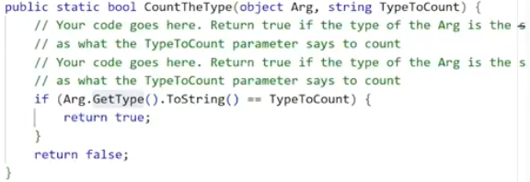

**Why can manipulating string objects be problematic?**

They are immutable, and the string is copied repeatedly when an operation is done on it, which adversely affects a computer's resources.

The StringBuilder class allows string manipulation while demanding less of a computer's resources.

**Clementia needs to parse string objects with exception handling. Which statement should she include in her code?**

"TryParse" can parse strings and also provide exception handling at the same time.

## Functions

using System;

// Functions are used to group re-usable code together in a single

// unit that can be customized with parameters.

// Functions have a return type, name, and optional parameters

float MilesToKm(float miles) {

    float result = miles * 1.6f;

    return result;

}

// A function with no return value has a 'void' type

void PrintWithPrefix(string thestr) {

    Console.WriteLine($"::> {thestr}");

}

// Call first function

Console.WriteLine($"The result is {MilesToKm(8.0f)}");

Console.WriteLine($"The result is {MilesToKm(52.0f)}");

// Call second function

PrintWithPrefix("Test string");

PrintWithPrefix("Another test string");

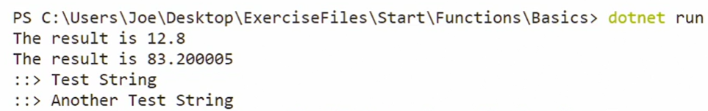

## Default parameters

using System;

// Functions can provide default values for their parameters

void PrintWithPrefix(string thestr, string prefix="")

{

    Console.WriteLine($"{prefix} {thestr}");

}

// Test the default parameters

PrintWithPrefix("Hello there!");

PrintWithPrefix("Hello there!", ">: ");

// Call with named params

PrintWithPrefix(prefix: "% ", thestr: "Hello there!");

## Reference and out values

The main purpose of the out parameter is to enable a function to return multiple values. It was used more in old C# code, but now a new way to do that is using a tuple structure.

using System;

namespace RefAndOutParams {

    class Program {

        // Ordinary value arguments cannot be modified by the function

        // because they are a copy of the original value

        static void TestFunc1(int arg1) {

            arg1 += 10;

            Console.WriteLine($"{arg1}");

        }

        // Arguments that are passed by reference can be modified

        // by the function and reflected back to the caller

        static void TestFunc2(ref int arg1) {

            arg1 += 10;

            Console.WriteLine($"{arg1}");

        }

        // The "out" keyword means that the parameter returns a value and is not

        // used to supply data to the function

        static void PlusTimes(int arg1, int arg2, out int sum, out int product) {

            sum = arg1 + arg2;

            product = arg1 * arg2;

        }

        static void Main(string[] args) {

            int val1 = 10;

            int val2 = 20;

            // Functions don't normally modify value arguments

            TestFunc1(val1);

            Console.WriteLine($"{val1}");

            // Using the "ref" keyword, arguments can be passed by reference

            // which allows the function to modify them

            TestFunc2(ref val1);

            Console.WriteLine($"{val1}");

            // The "out" keyword can be used to indicate that an argument

            // is intended to return a value and is not an input

            int a, b;

            PlusTimes(val1, val2, out a, out b);

            Console.WriteLine($"{a}, {b}");

        }

    }

}

## Returning multiple values with tuple:

using System;

namespace MultiValues

{

    class Program

    {

        static void Main(string[] args)

        {

            // Tuples are grouped values added in C# 7

            (int a, int b) tup1 = (5, 10);

            var tup2 = ("Some text", 10.5);

            // Tuple values are mutable

            tup1.b = 20;

            tup2.Item1 = "New String";

            Console.WriteLine($"{tup1.a},{tup1.b}");

            Console.WriteLine($"{tup2.Item1},{tup2.Item2}");

            // Functions can work with tuples

            (int, int) result = PlusTimes(6, 12);

            Console.WriteLine($"Sum: {result.Item1}, Product: {result.Item2}");

        }

        // Functions can return multiple values using tuples

        static (int, int) PlusTimes(int a, int b) {

            return (a+b, a*b);

        }

    }

}

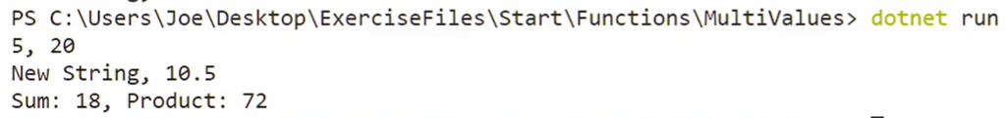

## Check palindrome.

// C# code​​​​​​‌​‌‌​‌‌​​‌​​​‌‌‌‌​‌​‌​‌‌‌ below

using System;

using System.Text;

// Write your answer here, and then test your code.

public class Answer {

    // Change these Boolean values to control whether you see

    // the expected result and/or hints.

   public  static Boolean ShowExpectedResult = false;

   public  static Boolean ShowHints = false;

    // Determine whether a string is a Palindrome

    public static bool IsPalindrome(string thestr) {

        // Your code goes here.

        thestr = thestr.Replace(" ", "");

        StringBuilder sb = new StringBuilder();

        for (int i = 0; i < thestr.Length; i++) {

            if (!char.IsPunctuation(thestr[i])) {

                sb.Append(char.ToLower(thestr[i]));

            }

        }

        string result = sb.ToString();

        char[] arr = result.ToCharArray();

        Array.Reverse(arr);

        string reversed = new string(arr);  // Convert char array back to string

        if (reversed == result) {

            return true;

        }

        return false;

    }

}

// This is how your code will be called.

// You can edit this code to try different testing cases.

string[] teststrings = { "Hello World!", "Race car!", "Rotor", "More cowbell!", "Madam, I'm Adam." };

int palcount = 0;

foreach (string str in teststrings) {

    bool learnerResult = Answer.IsPalindrome(str);

    if (learnerResult)

        palcount++;

}

**Questions**

A parameter val1 is passed by reference with a value of 0. Inside the function body, val1 is assigned a value of 5. What is the value of val1 when execution returns back from the function call?

5, Since the parameter is passed by reference, the changes that happen inside the function body are retained

How do you specify a parameter to be an output parameter?

Modify the parameter list when defining the function. Use the keyword out, followed by the data type and parameter name. Prefixing the keyword "out" before the parameter in the parameter list will change it to be used as output.

Michael needs to return two integer values from a function call. How can he do this with a single variable?

Define a function with a tuple (int, int) return type. Defining a tuple return type for a function is one possible way to return multiple values from a function call.

## Classes

Create a file Book.cs

using System;

namespace Defining

{

    // classes have a name, unique within the namespace

    public class Book

    {

        // classes have member variables, or "fields" to hold data

        string _name;

        string _author;

        int _pagecount;

        // classes have one or more constructors

        public Book(string name, string author, int pages) {

            _name = name;

            _author = author;

            _pagecount = pages;

        }

        // methods are used to operate on the class and data

        public string GetDescription() {

            return $"{_name} by {_author}";

        }

    }

}

Create the file Program.cs

using System;

namespace Defining

{

    class Program

    {

        static void Main(string[] args)

        {

            // Create new object instances using the "new" operator

            Book b1 = new Book("War and Peace", "Leo Tolstoy", 825);

            Book b2 = new Book("The Grapes of Wrath", "John Steinbeck", 464);

            // Call a method on the object

            Console.WriteLine(b1.GetDescription());

            Console.WriteLine(b2.GetDescription());

            // try to set one of the properties --

            // this will result in an error

            // b1._name = "Aldous Huxley";

        }

    }

}



## Access Modifiers

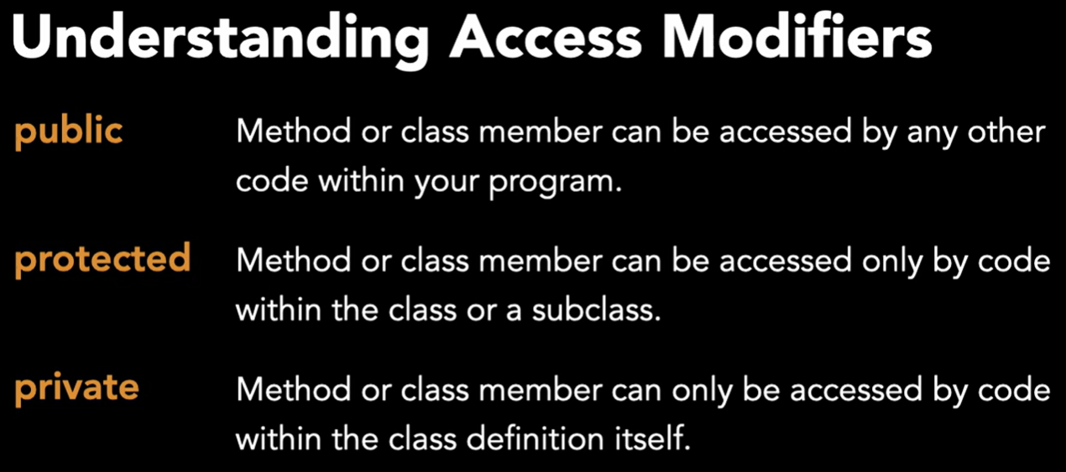

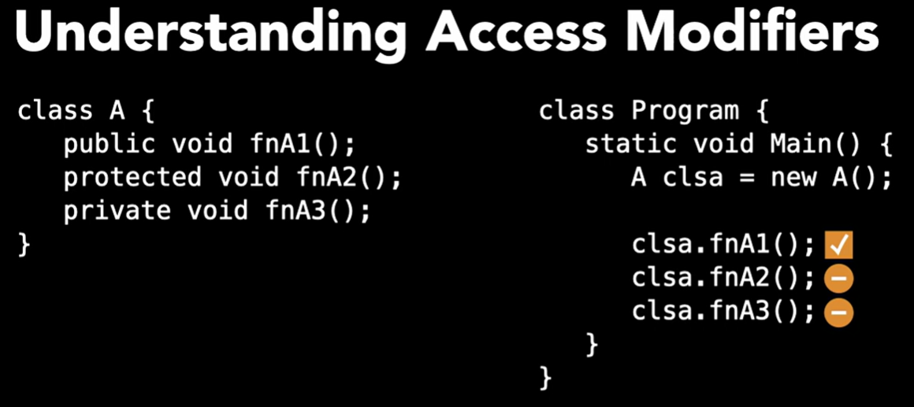

We can do into the class Program clsa.fnA1(); but we will not be able to do clsa.fnA2(); neither clsa.fnA3();

If we do this:

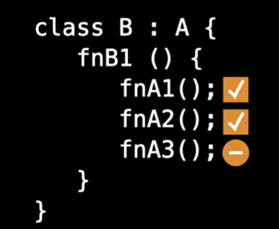

Here the class B derives from the class A, here we can access to fnA1(); and fnA2(); but the call to function fnA3(); is not allowed

## Defining properties

Book.cs

using System;

namespace Properties

{

    // classes have a name, unique within the namespace

    class Book

    {

        // classes have instance variables to hold data

        private string _name;

        private string _author;

        private int _pagecount;

        // classes have one or more constructors

        public Book(string name, string author, int pages) {

            _name = name;

            _author = author;

            _pagecount = pages;

        }

        // use Properties to implement access to our internal data

        // This is called a Property with a "backing field"

        public string Name {

            get {

                return _name;

            }

            set {

                _name = value;

            }

        }

        // There's a shorthand way of writing these using the => operator

        // to create "expression-bodied" properties

        public string Author {

            get => _author;

            set => _author = value;

        }

        public int Pagecount {

            get => _pagecount;

            set => _pagecount = value;

        }

        // You can omit the get or set if you want to prevent

        // modification or reading the value, or if you want to create

        // a "computed property" from other fields

        public string Description {

            get => $"{Name} by {Author}, {Pagecount} pages";

        }

        // Properties can be auto-generated - if there's no

        // backing field, the property can hold the data

        public string ISBN {

            get; set;

        }

        public decimal Price {

            get; set;

        }

    }

}

Program.cs

using System;

namespace Properties

{

    class Program

    {

        static void Main(string[] args)

        {

            // Create a new Book object

            Book b1 = new Book("War and Peace", "Leo Tolstoy", 825);

            // Access a couple of properties

            Console.WriteLine(b1.Name);

            Console.WriteLine(b1.Description);

            // Set the ISBN and Price properties

            b1.ISBN = "100140447938";

            b1.Price = 24.95m;

            Console.WriteLine(b1.ISBN);

            Console.WriteLine(b1.Price);

            // Change the Name and Pagecount

            b1.Name = "Crime and Punishment";

            b1.Pagecount = 652;

            Console.WriteLine(b1.Description);

            Console.WriteLine(b1.Name);

            Console.WriteLine(b1.Pagecount);

        }

    }

}

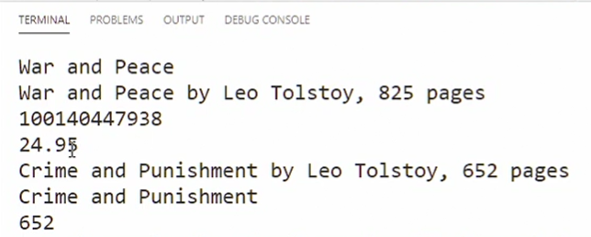

## Inheritance

Book.cs

using System;

namespace Inheritance

{

    // Declare "Book" as a subclass of Publication

    class Book : Publication {

        private string _author;

        // use the base() keyword to initialize the base class

        public Book(string name, string author, int pagecount, decimal price)

            : base(name, pagecount, price) {

            _author = author;

        }

        public string Author {

            get => _author;

            set => _author = value;

        }

        // use the override keyword to override a base class method

        public override string GetDescription() {

            return $"{Name} by {Author}, {PageCount} pages";

        }

    }

}

Publication.cs

using System;

namespace Inheritance

{

    class Publication

    {

        private string _name;

        public Publication(string name, int pagecount, decimal price) {

           _name = name;

           PageCount = pagecount;

           Price = price;

        }

        // The PageCount property has no backing field

        public int PageCount {

            get; set;

        }

        public decimal Price {

            get; set;

        }

        public string Name {

            // return the name

            get { return _name; }

            // use the setter to validate the new property value

            set {

                if (value == "") {

                    throw new ArgumentException("Name cannot be blank");

                }

                _name = value;

            }

        }

        // use the "virtual" keyword to indicate that a method

        // can be overridden by subclasses to customize behavior

        public virtual string GetDescription() {

            return $"{Name}, {PageCount} pages";

        }

    }

}

Magazine.cs

using System;

namespace Inheritance

{

    // Declare "Magazine" as a subclass of Publication

    class Magazine : Publication {

        private string _publisher;

        // use the base() keyword to initialize the base class

        public Magazine(string name, string publisher, int pagecount, decimal price)

             : base(name, pagecount, price) {

            _publisher = publisher;

        }

        public string Publisher {

            get => _publisher;

            set => _publisher = value;

        }

    }

}

Program.cs

using System;

namespace Inheritance

{

    class Program

    {

        static void Main(string[] args)

        {

            // Create some publications

            Book b1 = new Book("War and Peace", "Leo Tolstoy", 825, 39.95m);

            Magazine m1 = new Magazine("Time", "Time USA, LLC", 75, 4.95m);

            Console.WriteLine($"{b1.Name}, {b1.Author}");

            Console.WriteLine($"{m1.Name}, {m1.Publisher}");

            // Property validation logic will prevent an empty name

            // b1.Name = "";

            // Call the override functions

            Console.WriteLine(b1.GetDescription());

            Console.WriteLine(b1.Price);

            Console.WriteLine(m1.GetDescription());

            Console.WriteLine(m1.Price);

        }

    }

}

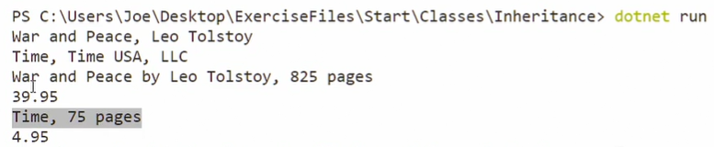

## String Representation

Book.cs

using System;

namespace StringRep {

    class Book {

        public string Name { get; set; }

        public string Author { get; set; }

        public int PageCount { get; }

        public Book(string name, string author, int pages) {

            Name = name;

            Author = author;

            PageCount = pages;

        }

        // The ToString method generates a string represenation of the object

        public override string ToString() {

            return $"Book: {Name} by {Author}";

        }

        // ToString can be overloaded to give different format versions

        // Notice that this version is NOT an override function

        public string ToString(char format) {

            if (format == 'B') {

                return $"Book: {Name}:{Author}";

            }

            else if (format == 'F') {

                return $"Book: {Name} by {Author} is {PageCount} pages";

            }

            else {

                return ToString();

            }

        }

    }

}

Program.cs

using System;

namespace StringRep

{

    class Program

    {

        static void Main(string[] args)

        {

            // Every class in C# inherits from Object, which means

            // that every class inherits the ToString() method

            int x = 1000;

            Console.WriteLine(x.ToString());

            // if you don't override the method, the default behavior just prints

            // the name of the class and the namespace

            object a = new object();

            Console.WriteLine(a.ToString());

            Book b1 = new Book("War and Peace", "Leo Tolstoy", 825);

            Console.WriteLine(b1.ToString());

            Console.WriteLine(b1);

            Console.WriteLine(b1.ToString('B'));

            Console.WriteLine(b1.ToString('F'));

        }

    }

}

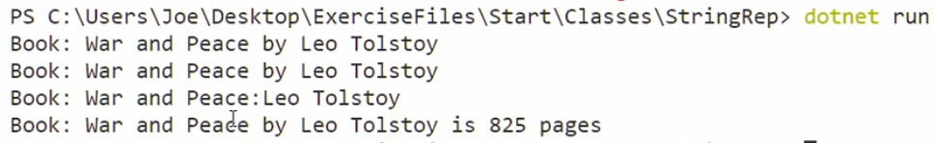

**Which access modifier allows members and methods to be accessed only by the class itself?**

Private. A "private" member or method can only be accessed by the class where it is defined.

**Which syntax is an "expression-bodied" property?**

public string Name {

get => _name;

set => _name = value;

}

**What is the correct syntax to declare Book as a subclass of Publication?**

class Book : Publication { <..> }

**What happens when you create a custom class and try to output it to the console without creating a ToString() method?**

The compiler uses the default implementation of the ToString() method, which prints the namespace and class name.

**When you define a class and then use the *new* keyword, what entity are you creating?**

an object instance of the class

**If you create an object instance from a class, what do you use to access the object's fields?**

dot syntax

### **Create a class hierarchy to represent bank accounts**

Implement a class hierarchy that represents basic banking operations for a checking and savings account.

You should have a **base class** that implements basic operations:

* A constructor that accepts the first and last name of the account holder as strings along with a decimal value for the starting balance, with a default value of 0.0m
* Balance: A decimal read and write property that contains the account balance
* AccountOwner: A get-only string that returns the full name of the account owner, for example, "John Doe"
* Deposit: A function that accepts a decimal argument, the amount to deposit
* Withdraw: A function that accepts a decimal argument, the amount to withdraw

There should be two subclasses of your base class: **CheckingAcct** and **SavingsAcct**.

CheckingAcct should have:

* A constructor that accepts the same arguments as the base account class
* An override of Withdraw, which checks to see if the amount being withdrawn exceeds the current balance; if so, the account is charged a $35 fee and the withdrawal is allowed

SavingsAcct should have:

* A constructor that accepts the same arguments as the base account class
* InterestRate: A read and write decimal property that contains the interest rate
* ApplyInterest: A function that applies the interest rate to the current balance
* Withdraw: An override of the Withdraw function that checks to see if the withdrawal amount exceeds the balance and prevents the withdrawal; if there are more than three withdrawals, then the account is charged a withdrawal charge of $2

Your code will be called with the test code you see to the right.

// C# code​​​​​​‌​‌‌​‌‌​​‌​​‌‌‌‌‌​‌‌​​​​‌ below

using System;

// Write your answer here, and then test your code.

// Your job is to implement the findLargest() method.

public class Answer {

    // Change these Boolean values to control whether you see

    // the expected result and/or hints.

   public  static Boolean ShowExpectedResult = true;

   public  static Boolean ShowHints = true;

}

public class BankAccount {

    private string _firstname;

    private string _lastname;

    public decimal Balance {

        get; set;

    }

    // classes have one or more constructors

    public BankAccount(string name, string lastname, decimal start_balance=0.0m) {

        _firstname = name;

        _lastname = lastname;

        Balance = start_balance;

    }

    public string AccountOwner {

        get => $"{_firstname} {_lastname}";

    }

    public virtual void Deposit(decimal amount) { // it is virtual since can be overriten by subclasses to further customize their behaviors

        Balance += amount;

    }

    public virtual void Withdraw(decimal amount) {

        Balance -= amount;

    }

}

public class CheckingAcct : BankAccount {

    private const decimal OVERDRAW_CHARGE = 35.0m;

    public CheckingAcct(string fname, string lname, decimal start) : base (fname, lname, start) {}

    public override void Withdraw(decimal amount) {

        // if the account gets overdrawn add an extra charge

        if (amount > Balance) {

            amount += OVERDRAW_CHARGE;

        }

        base.Withdraw(amount);

    }

}

public class SavingsAcct : BankAccount {

    private int _withdrawcount = 0;

    private const decimal WITHDRAW_CHARGE = 2.0m;

    private const int WITHDRAW_LIMIT = 3;

    public SavingsAcct(string fname, string lname, decimal interest, decimal start) : base(fname, lname, start) {

        InterestRate = interest;

    }

    public decimal InterestRate {

        get; set;

    }

    public void ApplyInterest() {

        // Add the new amount to the existing balance

        Balance += (Balance * InterestRate);

    }

    public override void Withdraw(decimal amount)

        // Don't allow overdraw, print a denial message

        {

            if (amount > Balance) {

                Console.WriteLine("Attempt to overdraw savings denied.");

            }

            else {

                base.Withdraw(amount);

                // Charge for more than 3 withdrawals

                _withdrawcount++;

                if (_withdrawcount > WITHDRAW_LIMIT) {

                    Console.WriteLine("More than 3 withdrawls. Extra charge");

                    base.Withdraw(WITHDRAW_CHARGE);

                }

            }

        }

}